Assignment 1

Login into AWS console and navigate to compute then EC2

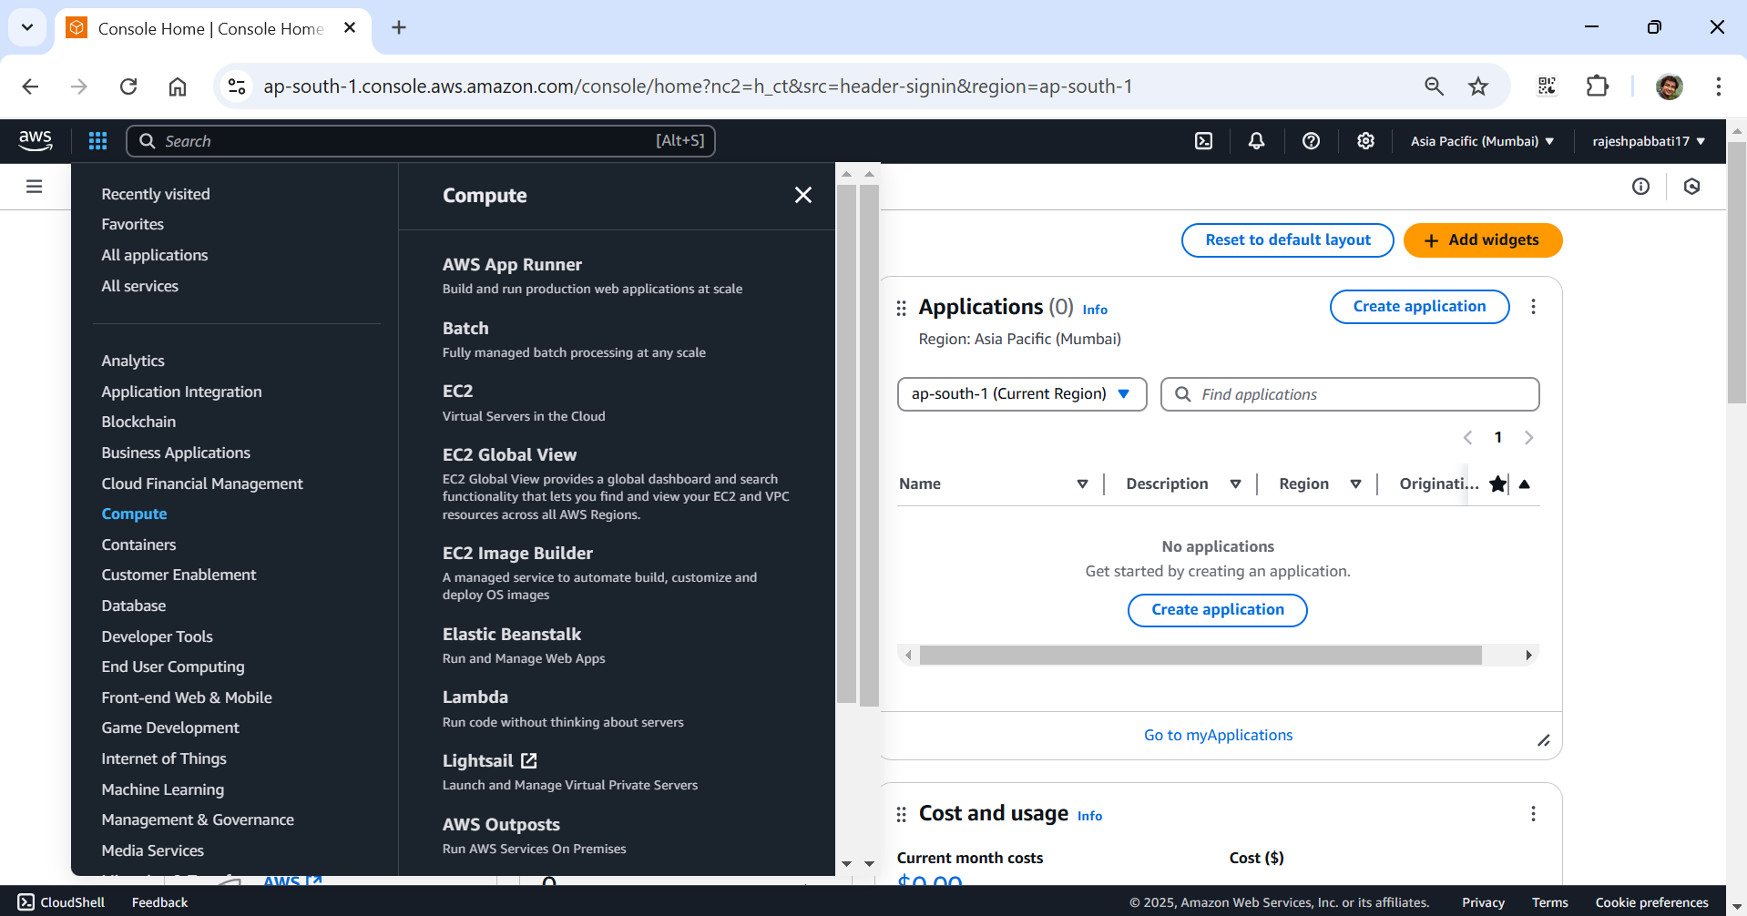

Click on instances

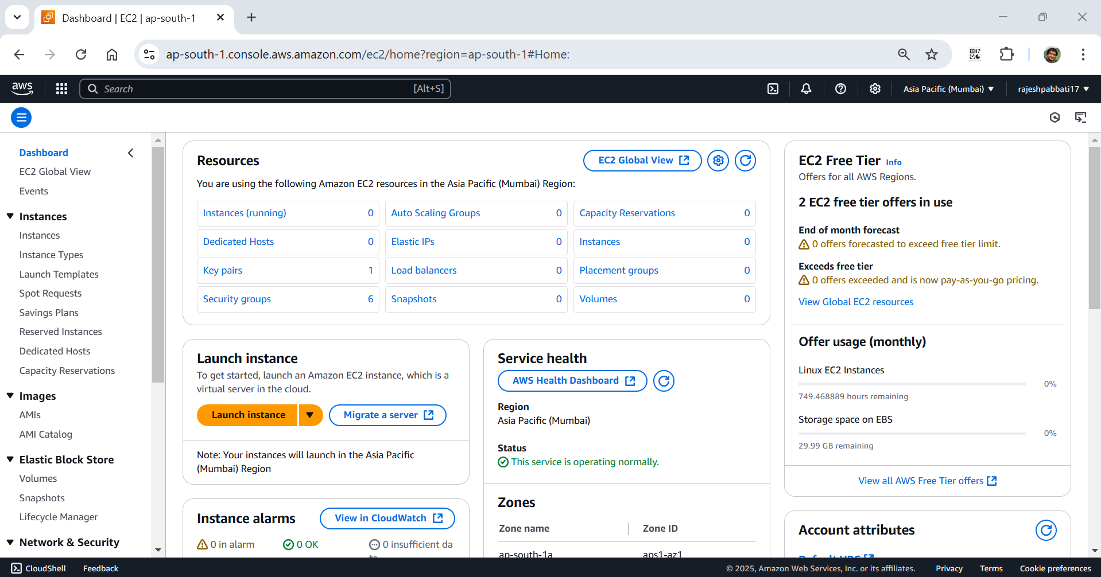

Click on launch instance

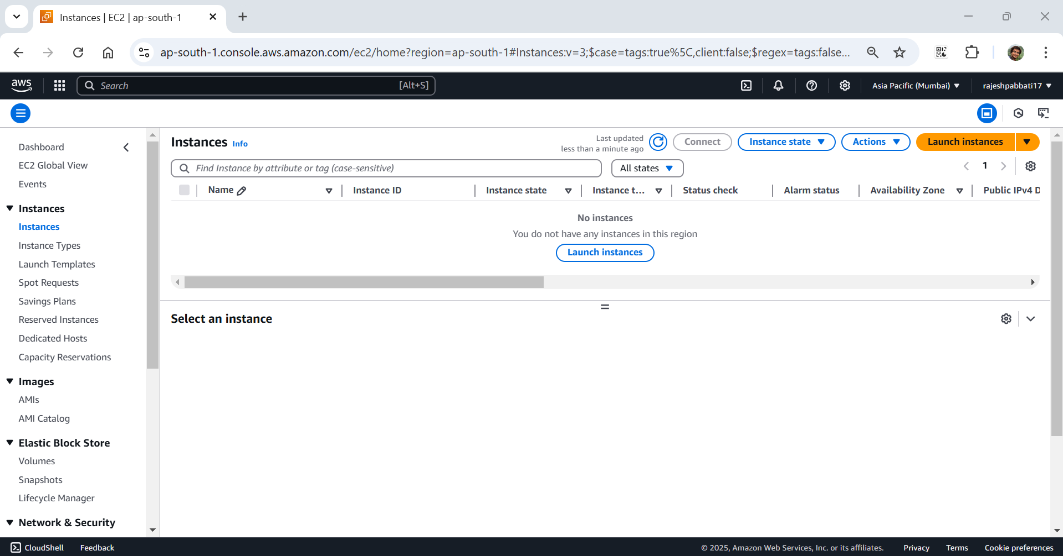

Enter name and default AMI

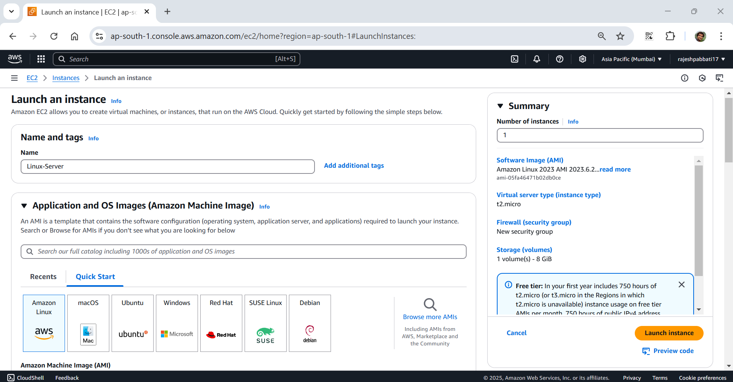

Select keypair

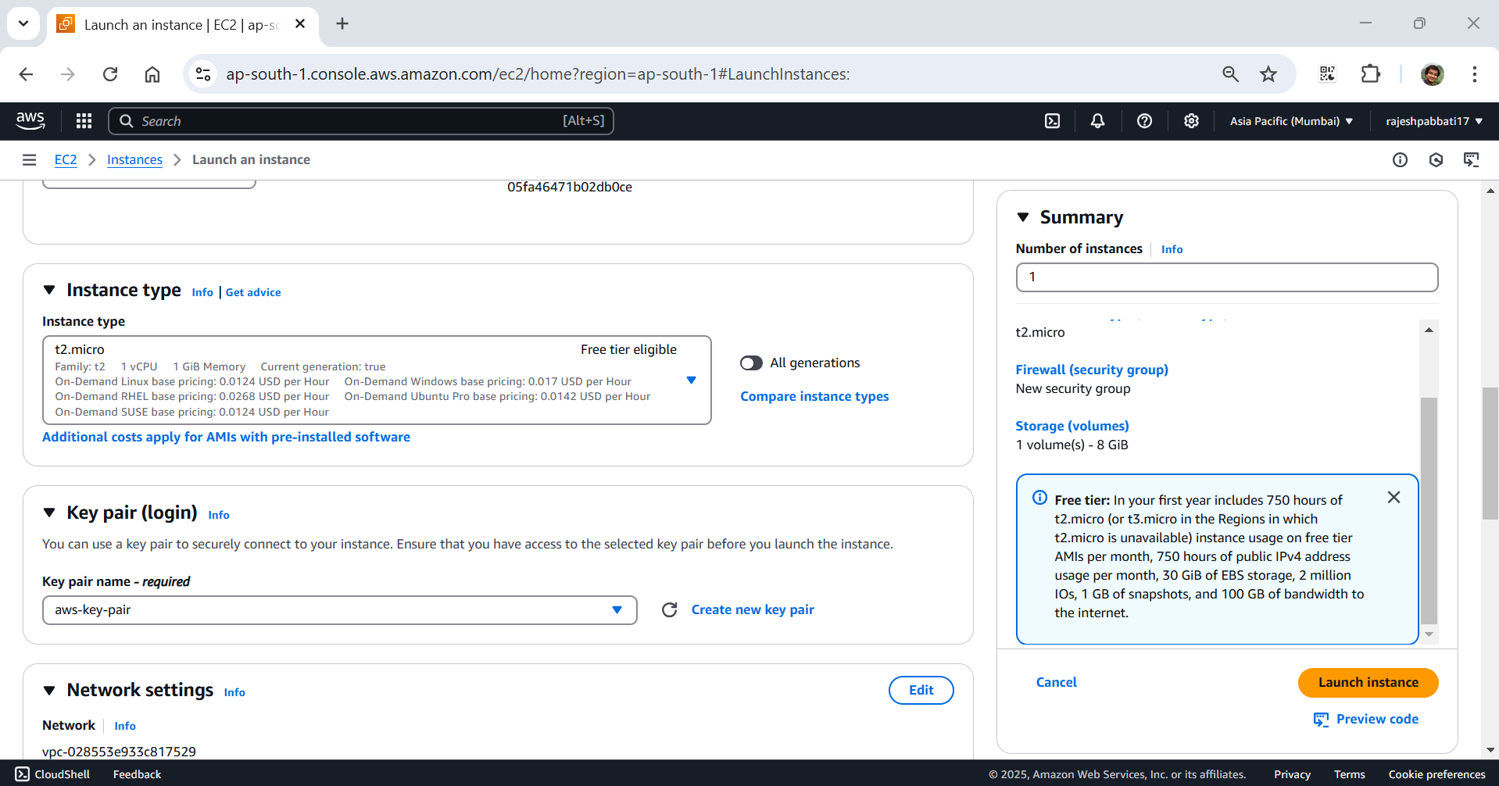

Select security group Linux which allows SSH and HTTP

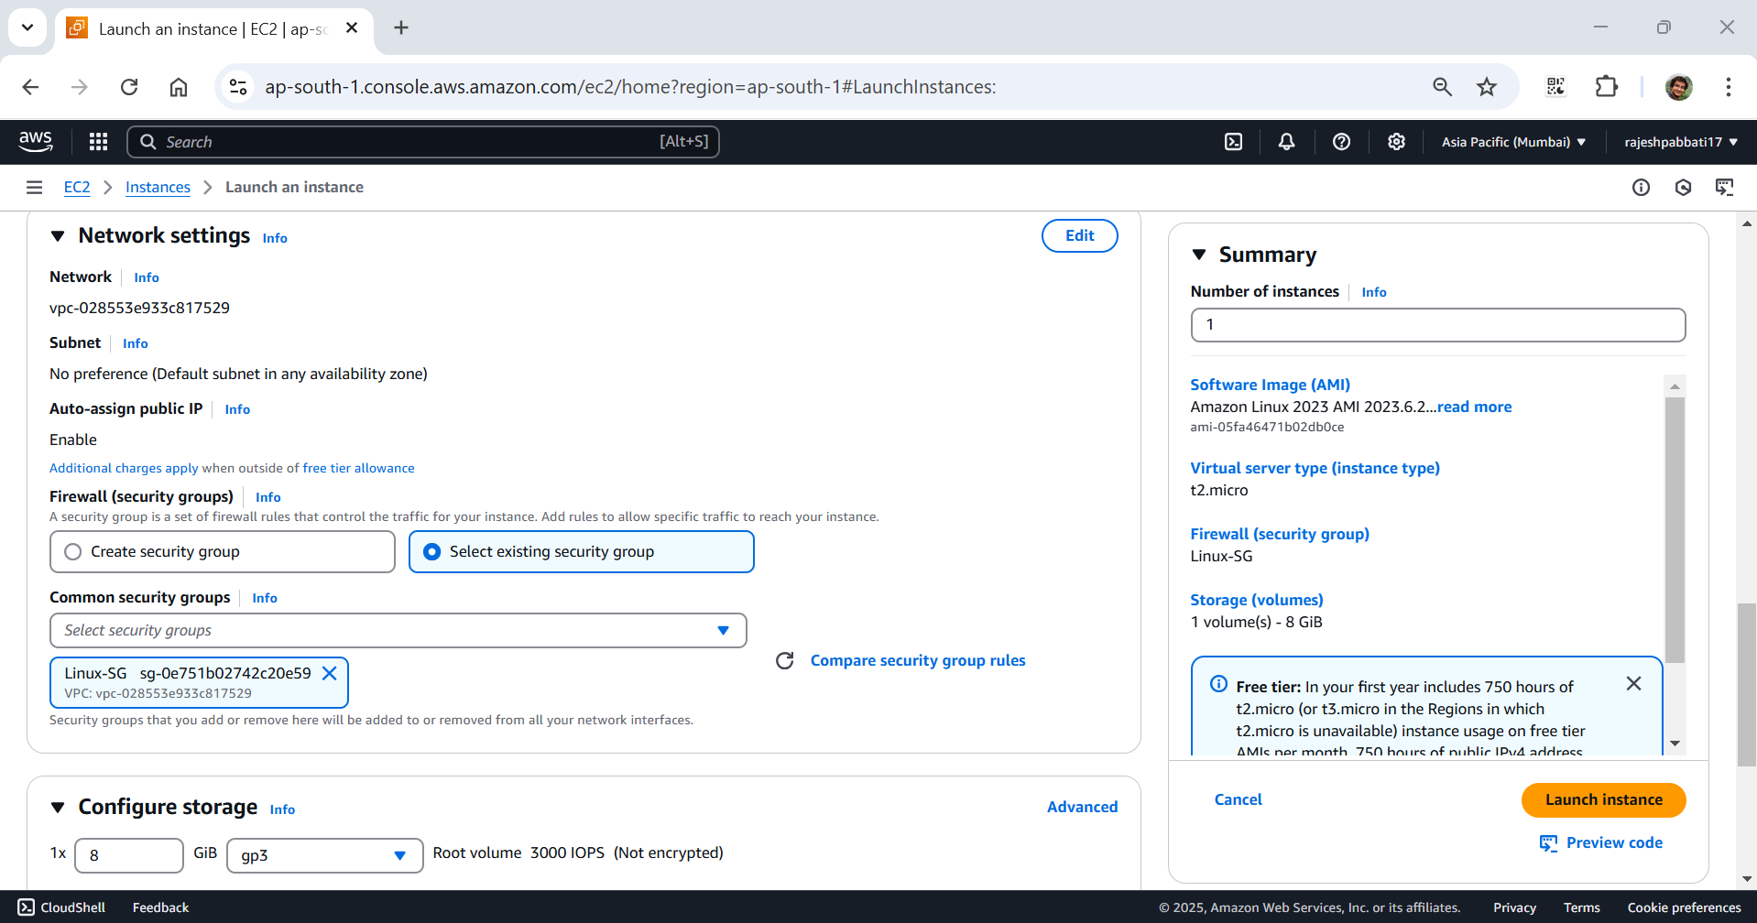

Select the instance click on actions -> image and templates -> create image

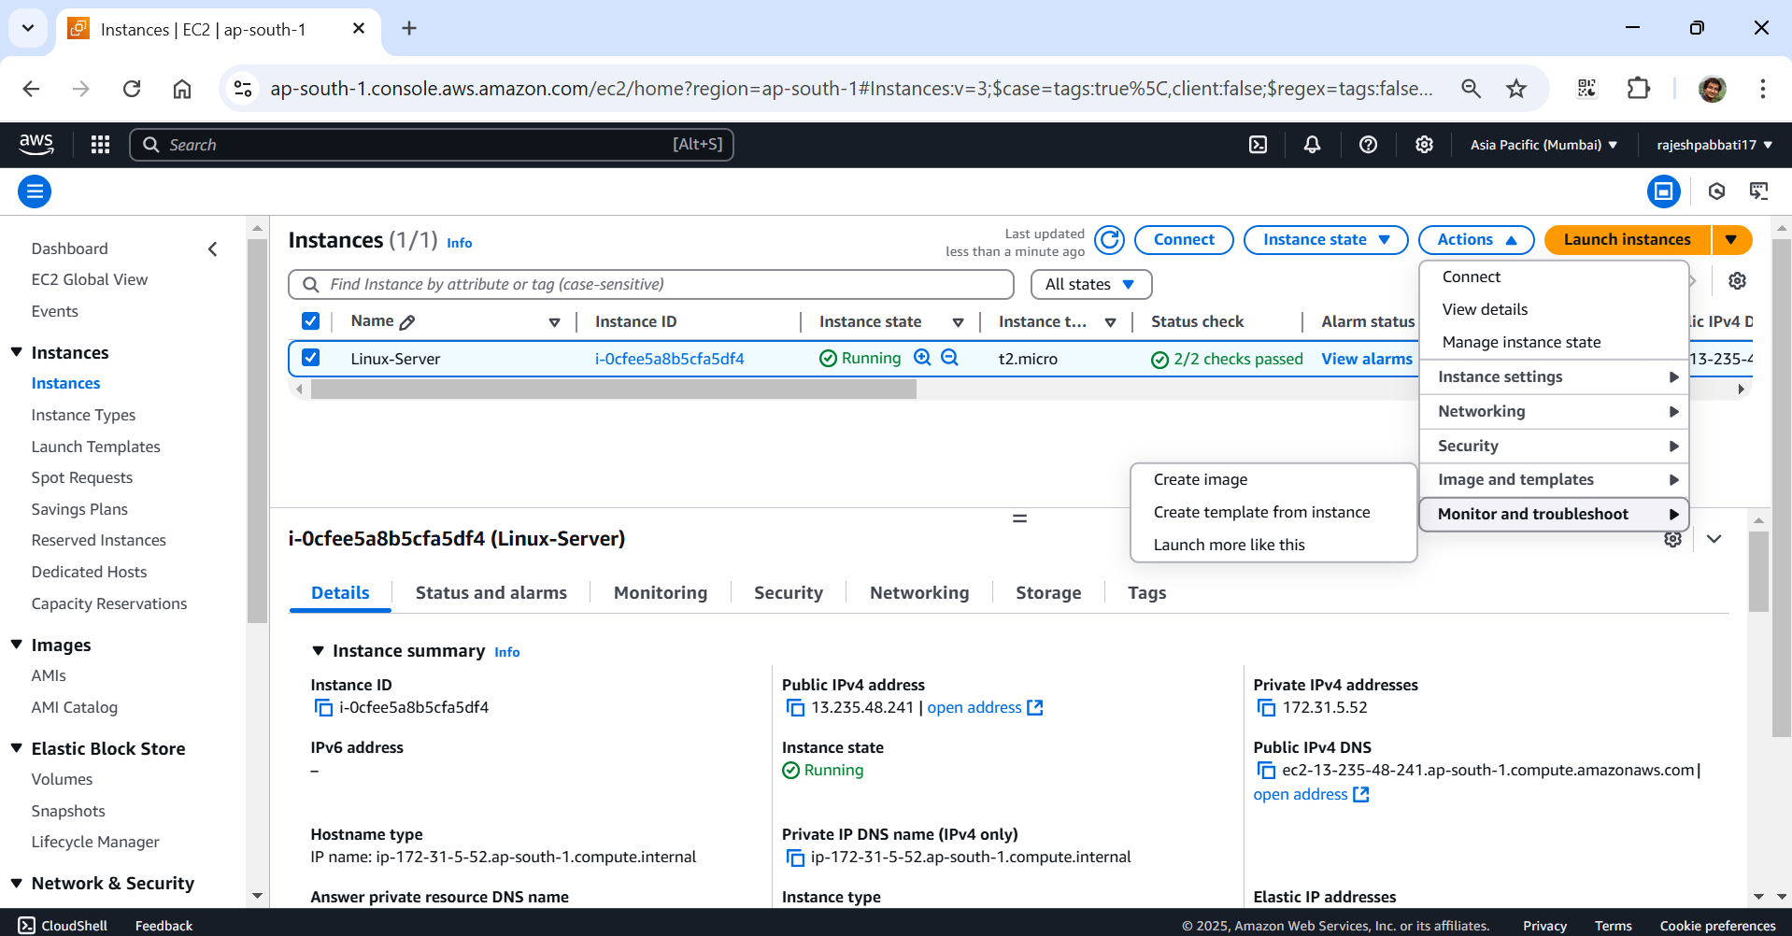

Give image name, image description and click create image

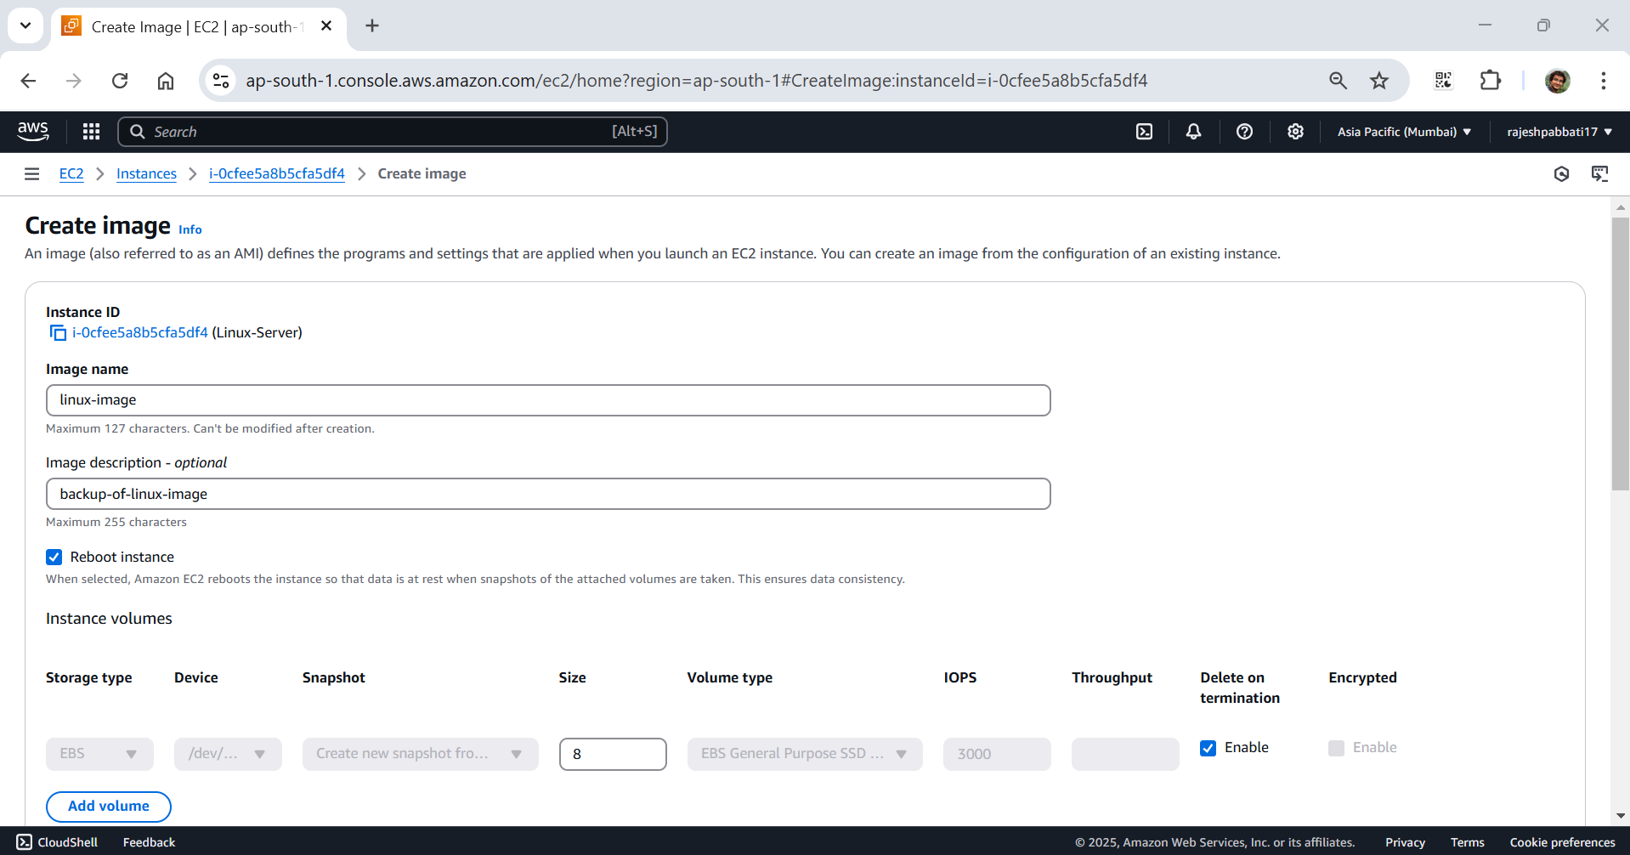

Image is created which is shown in Images -> AMIs

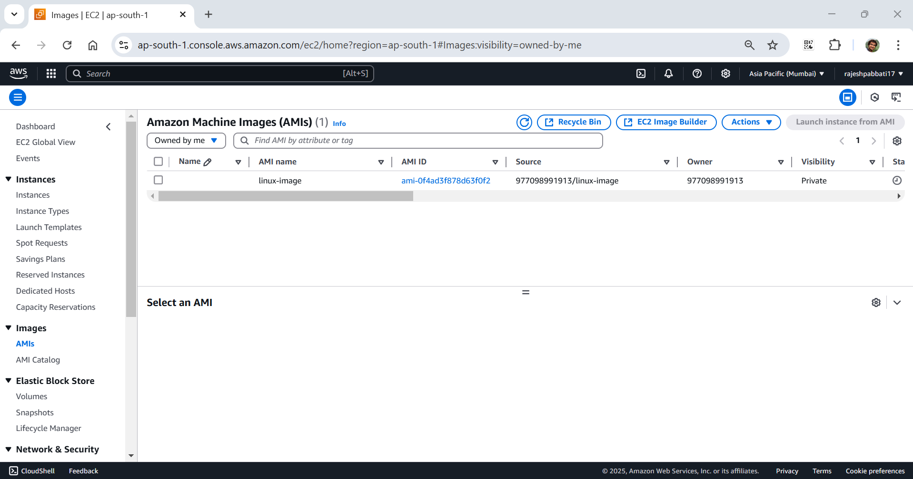

Got to instances and click on launch instance

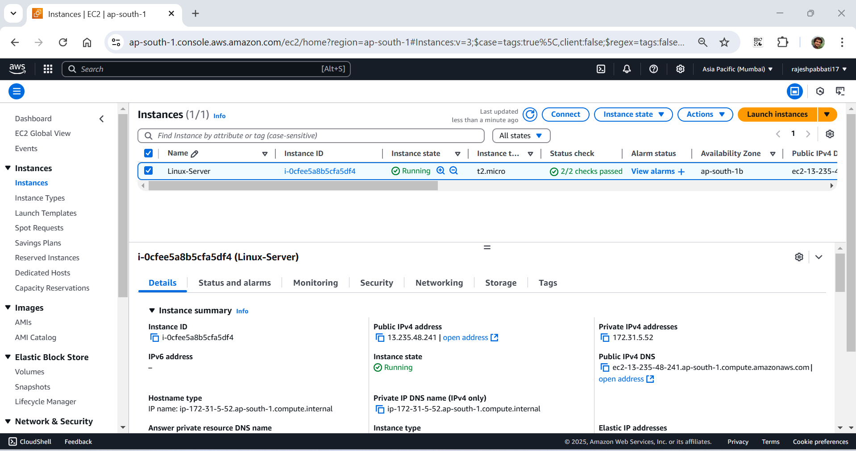

Give name

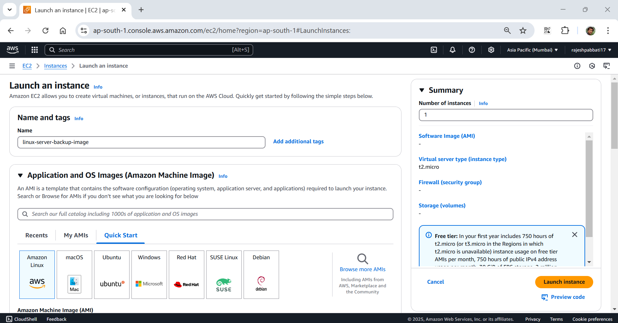

Select My AMIs

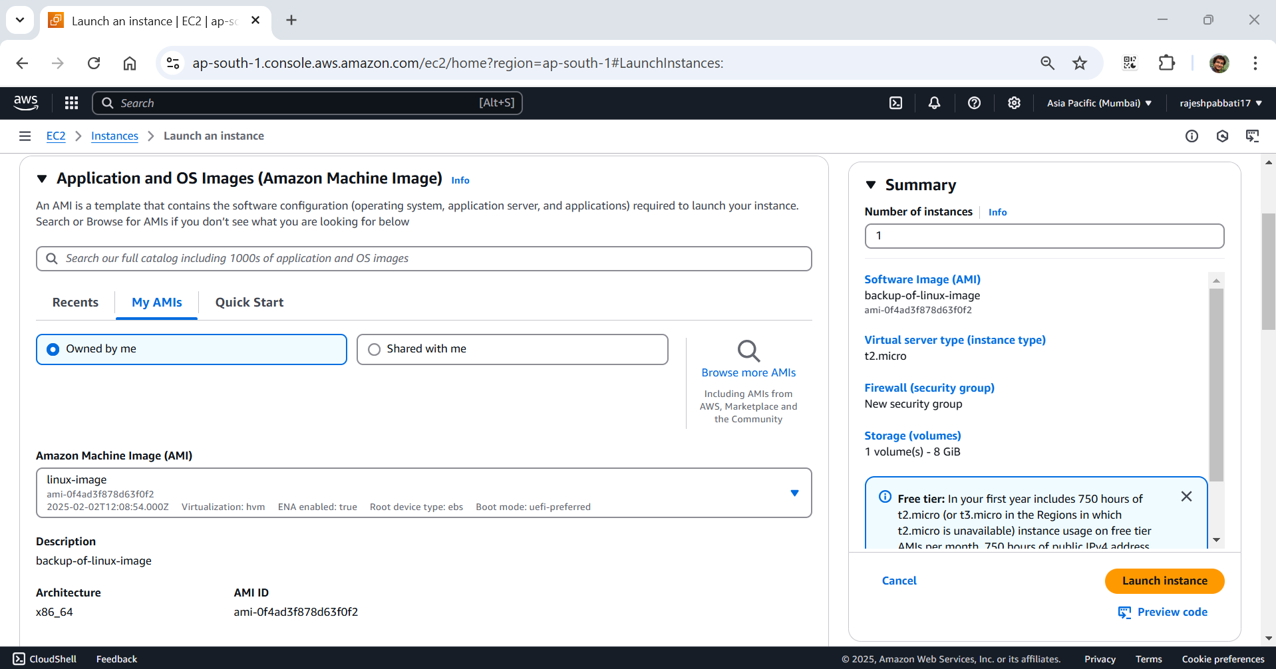

Select key pair and security group Linux-SG and click on launch instance

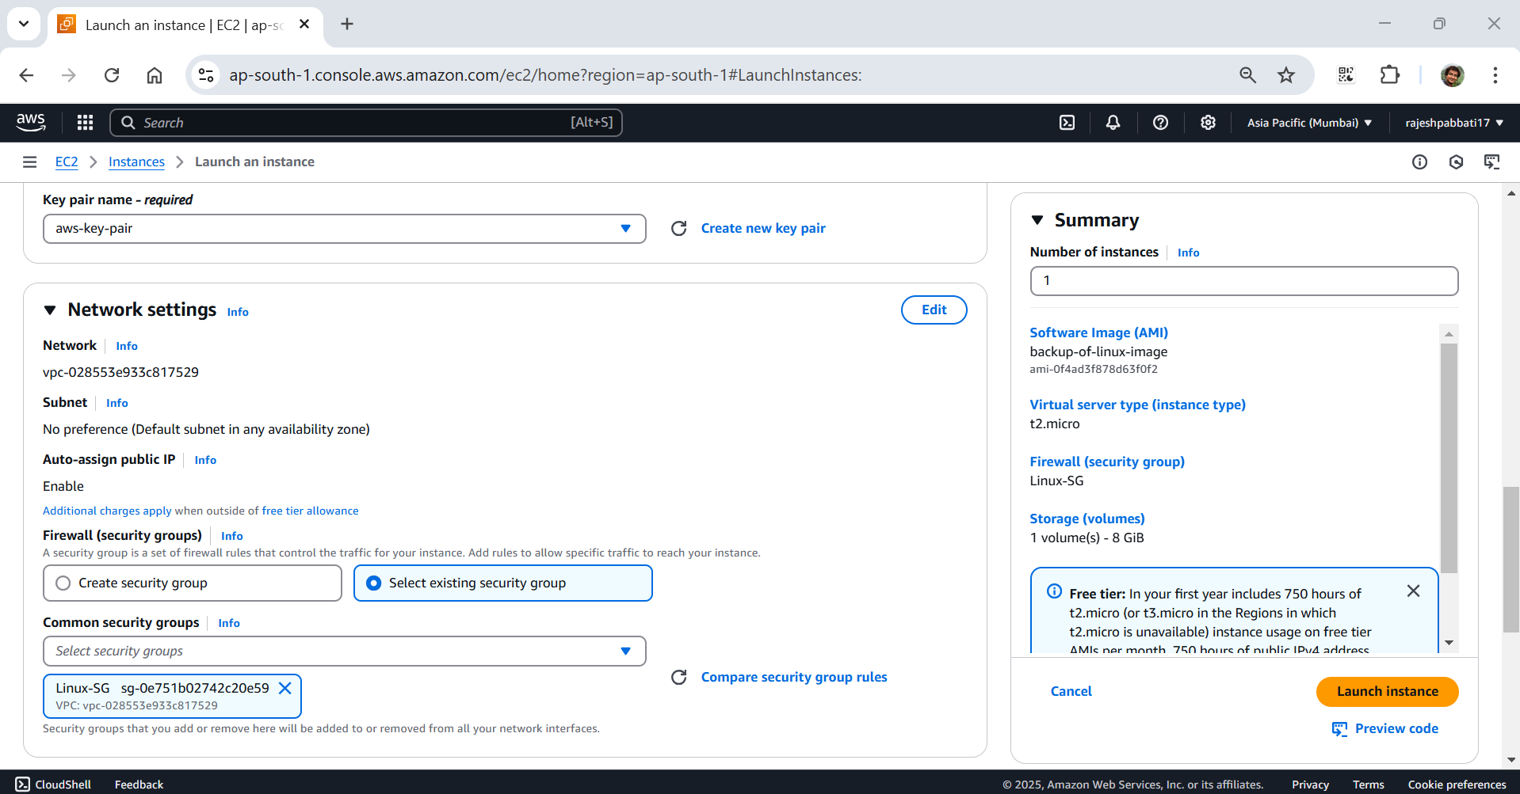

Instance is created with backup image - AMIs

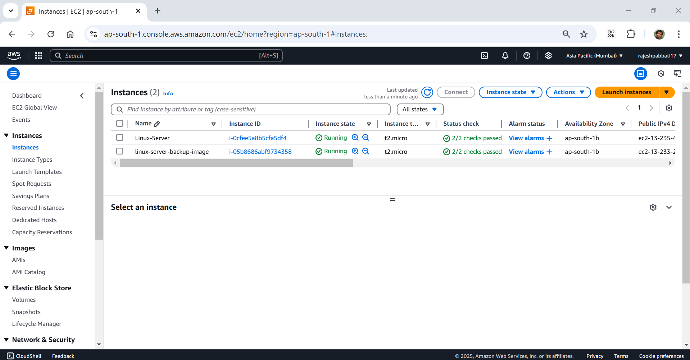

Click on volumes under Elastic Block Store

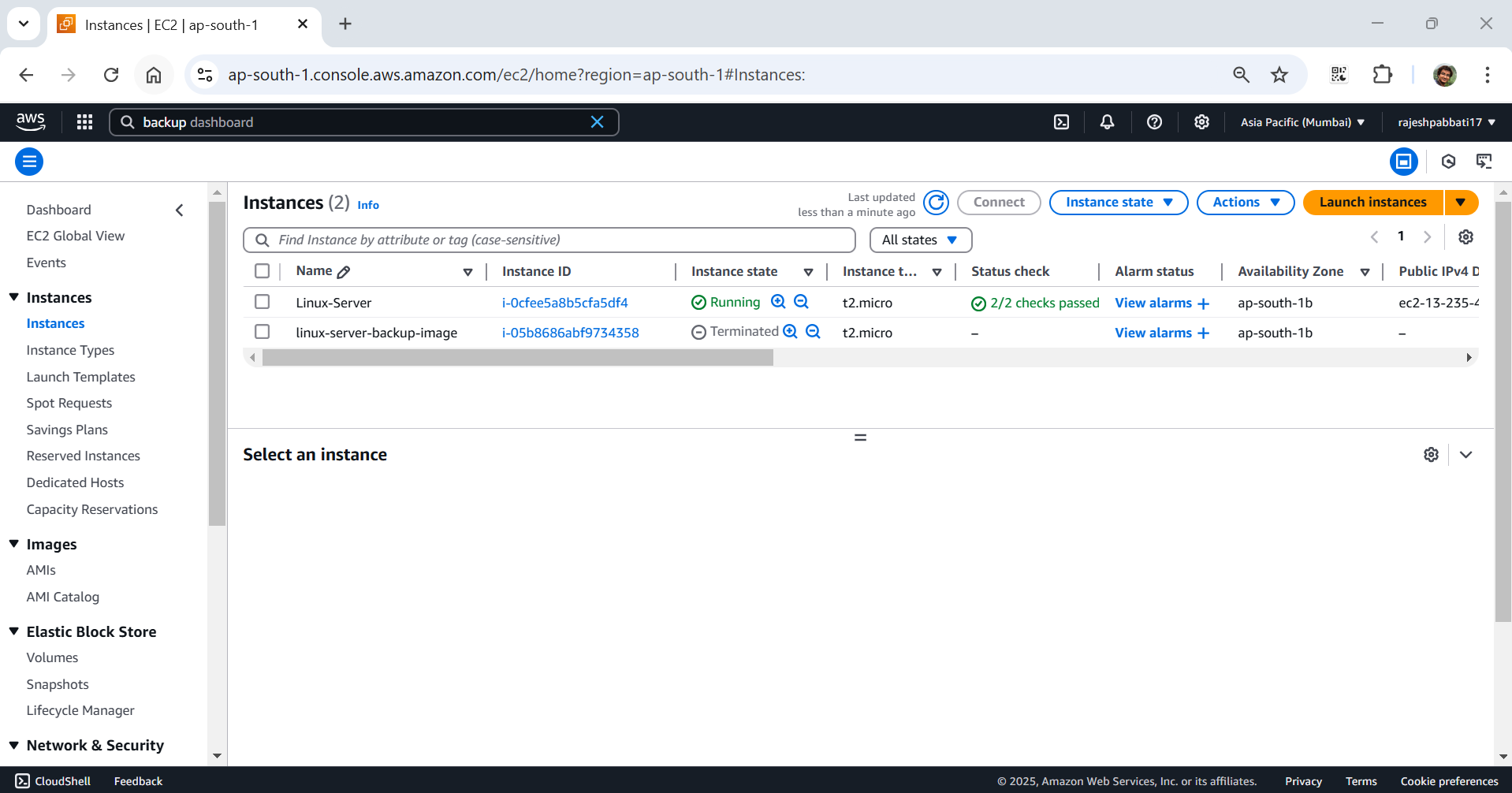

Click on Create volume

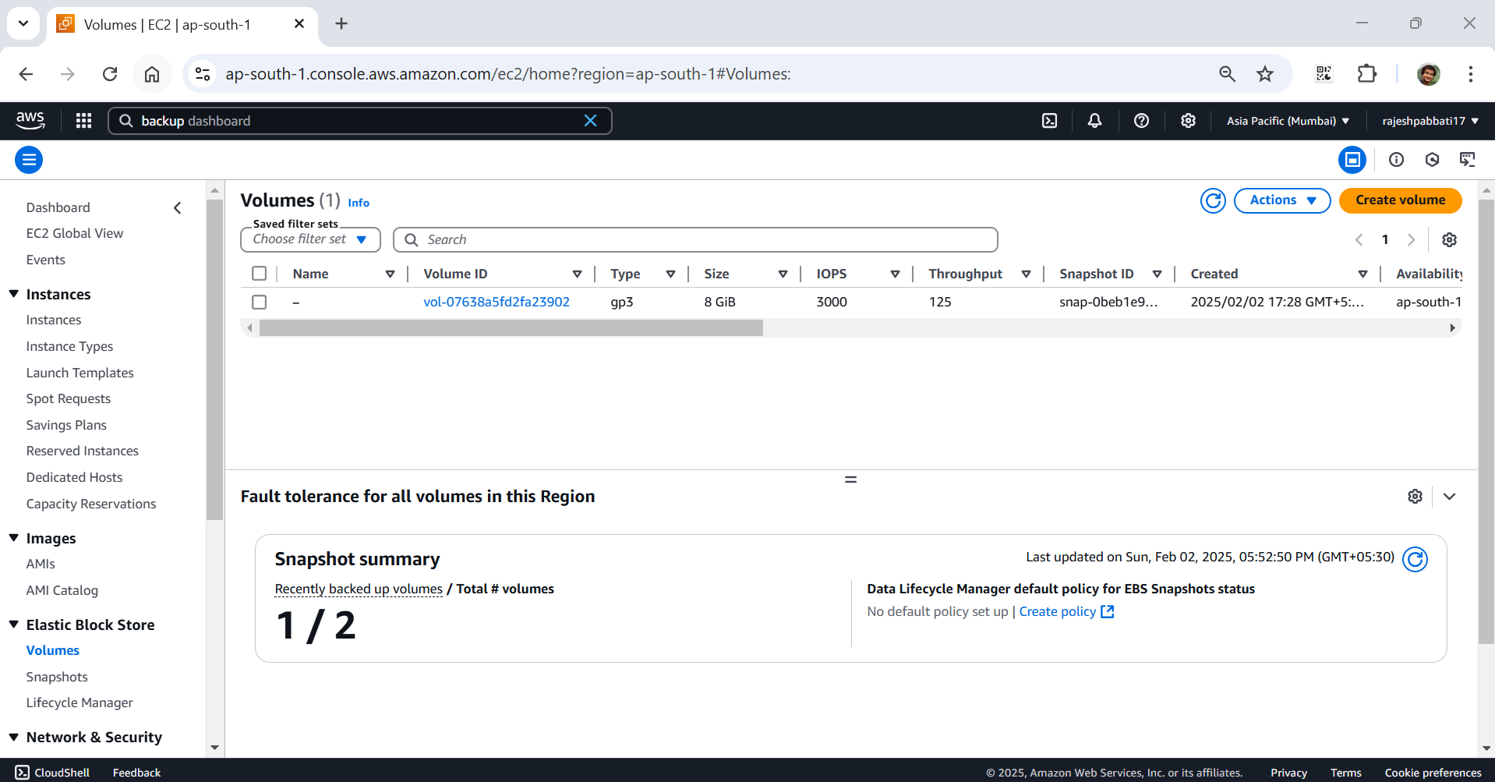

Select size 2 GB and availability zone as instance

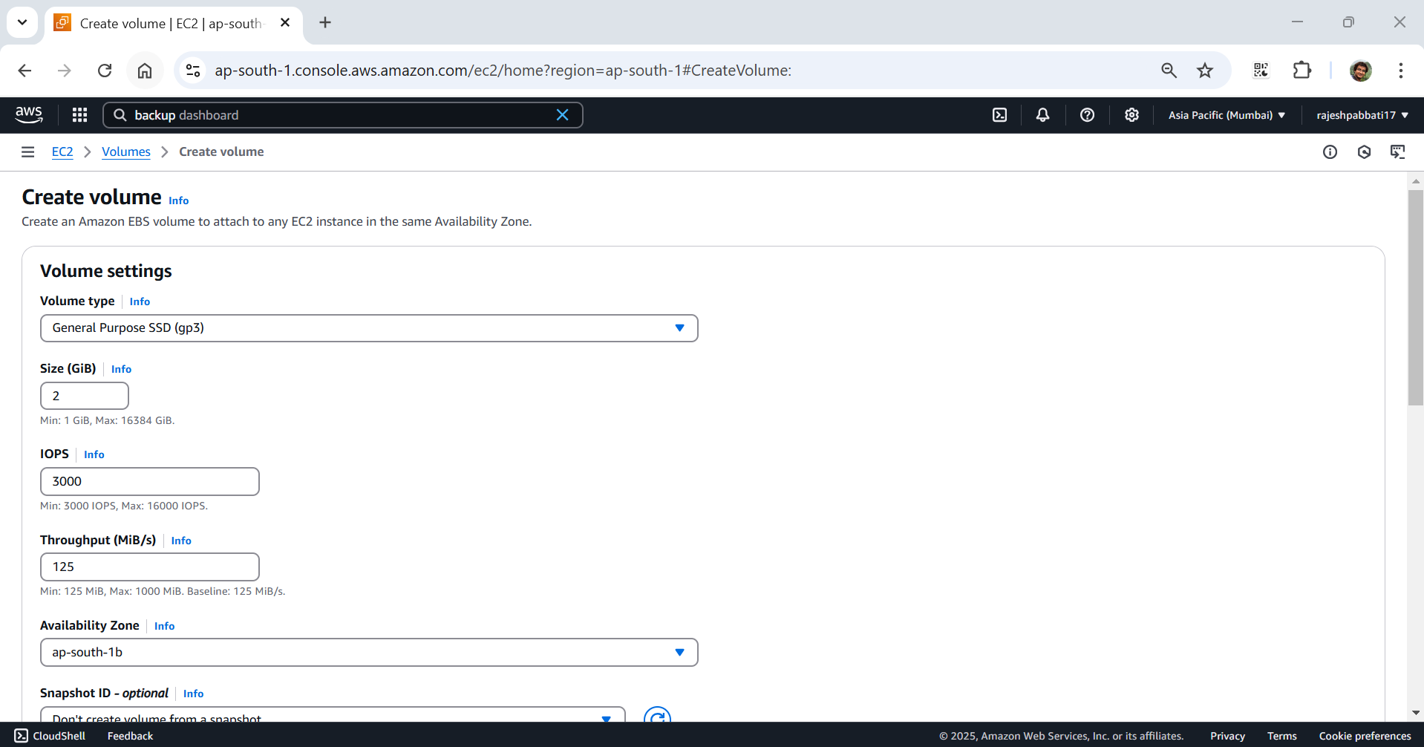

Give name and value and click on create volume

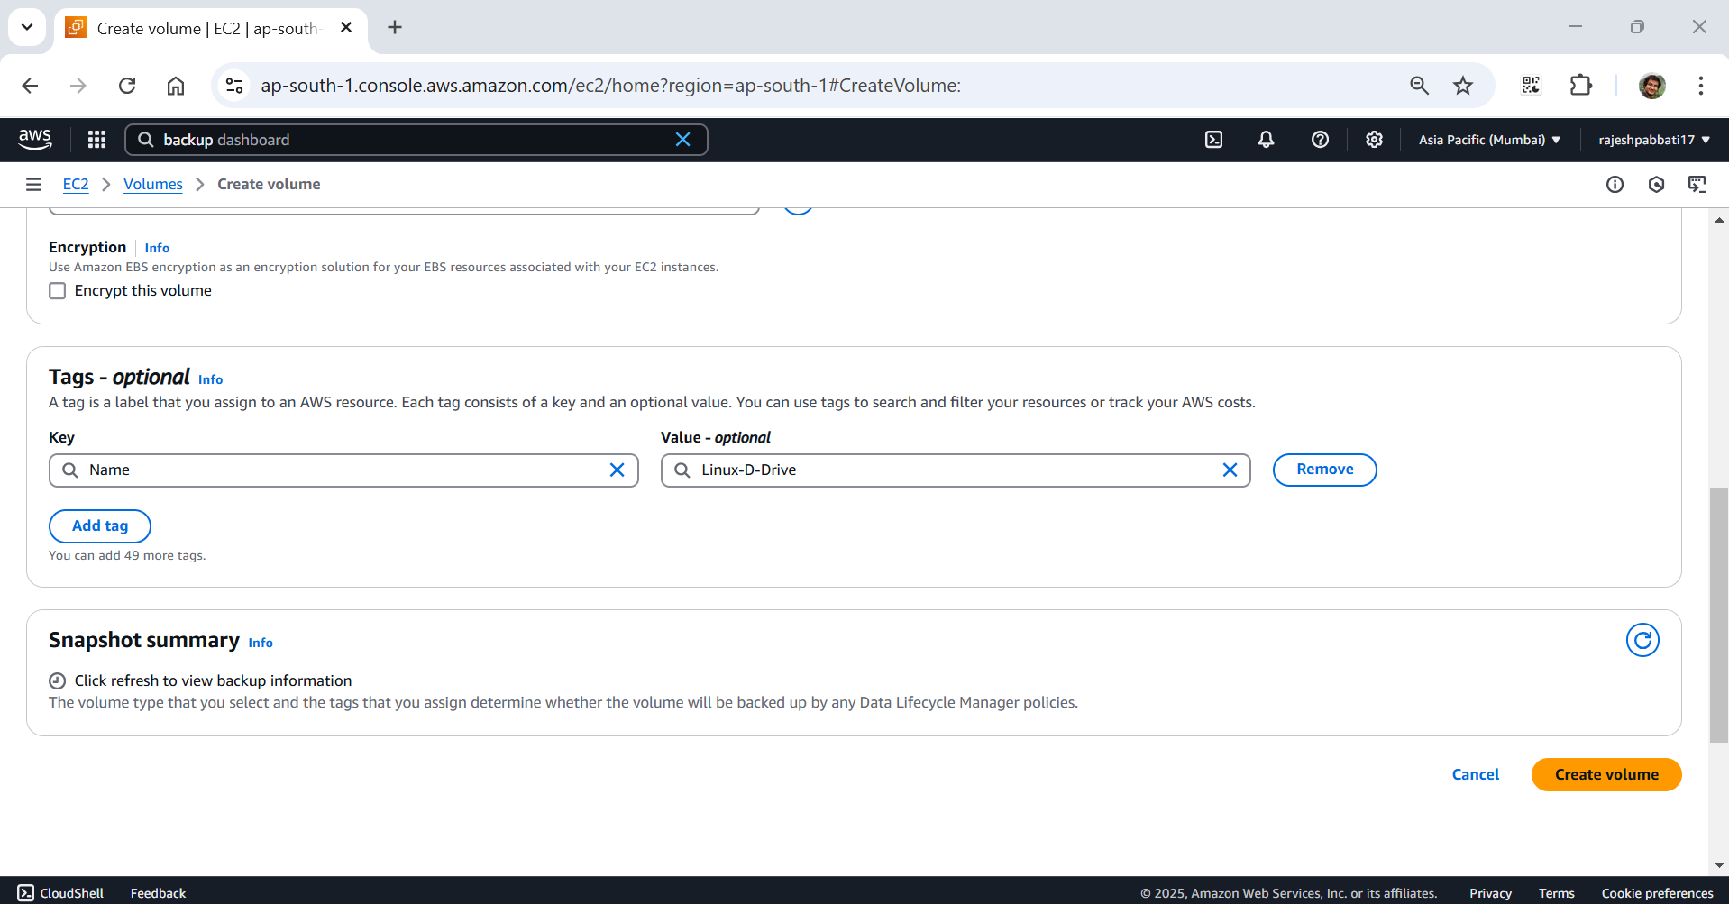

Volume with name Linux-D-Drive is created select and click on attach volume

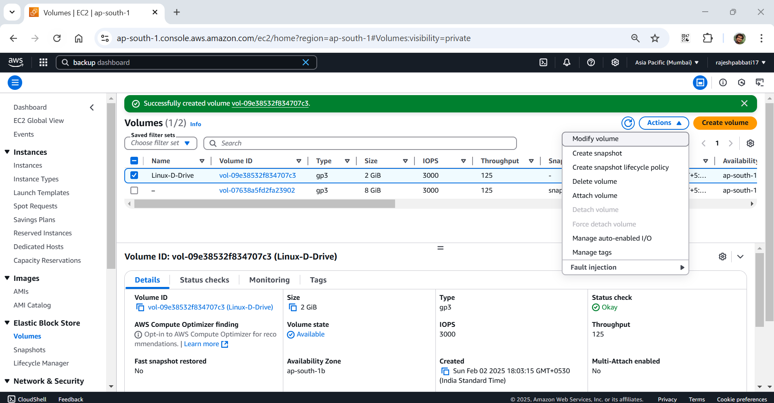

Select the instance and Device name as /dev/xvdbd and click on attach volume

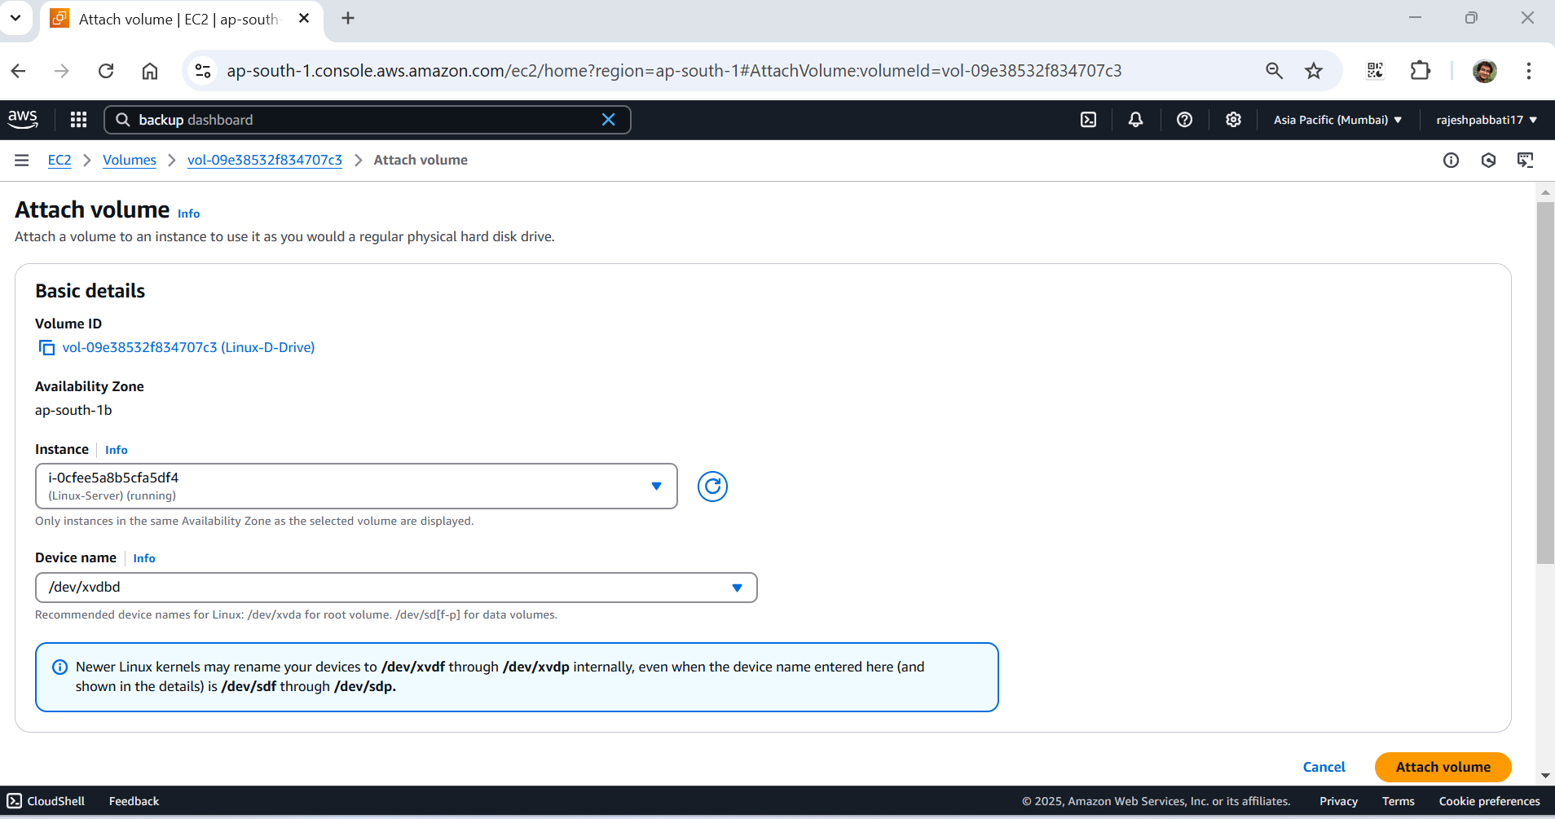

Select the server and click on connect

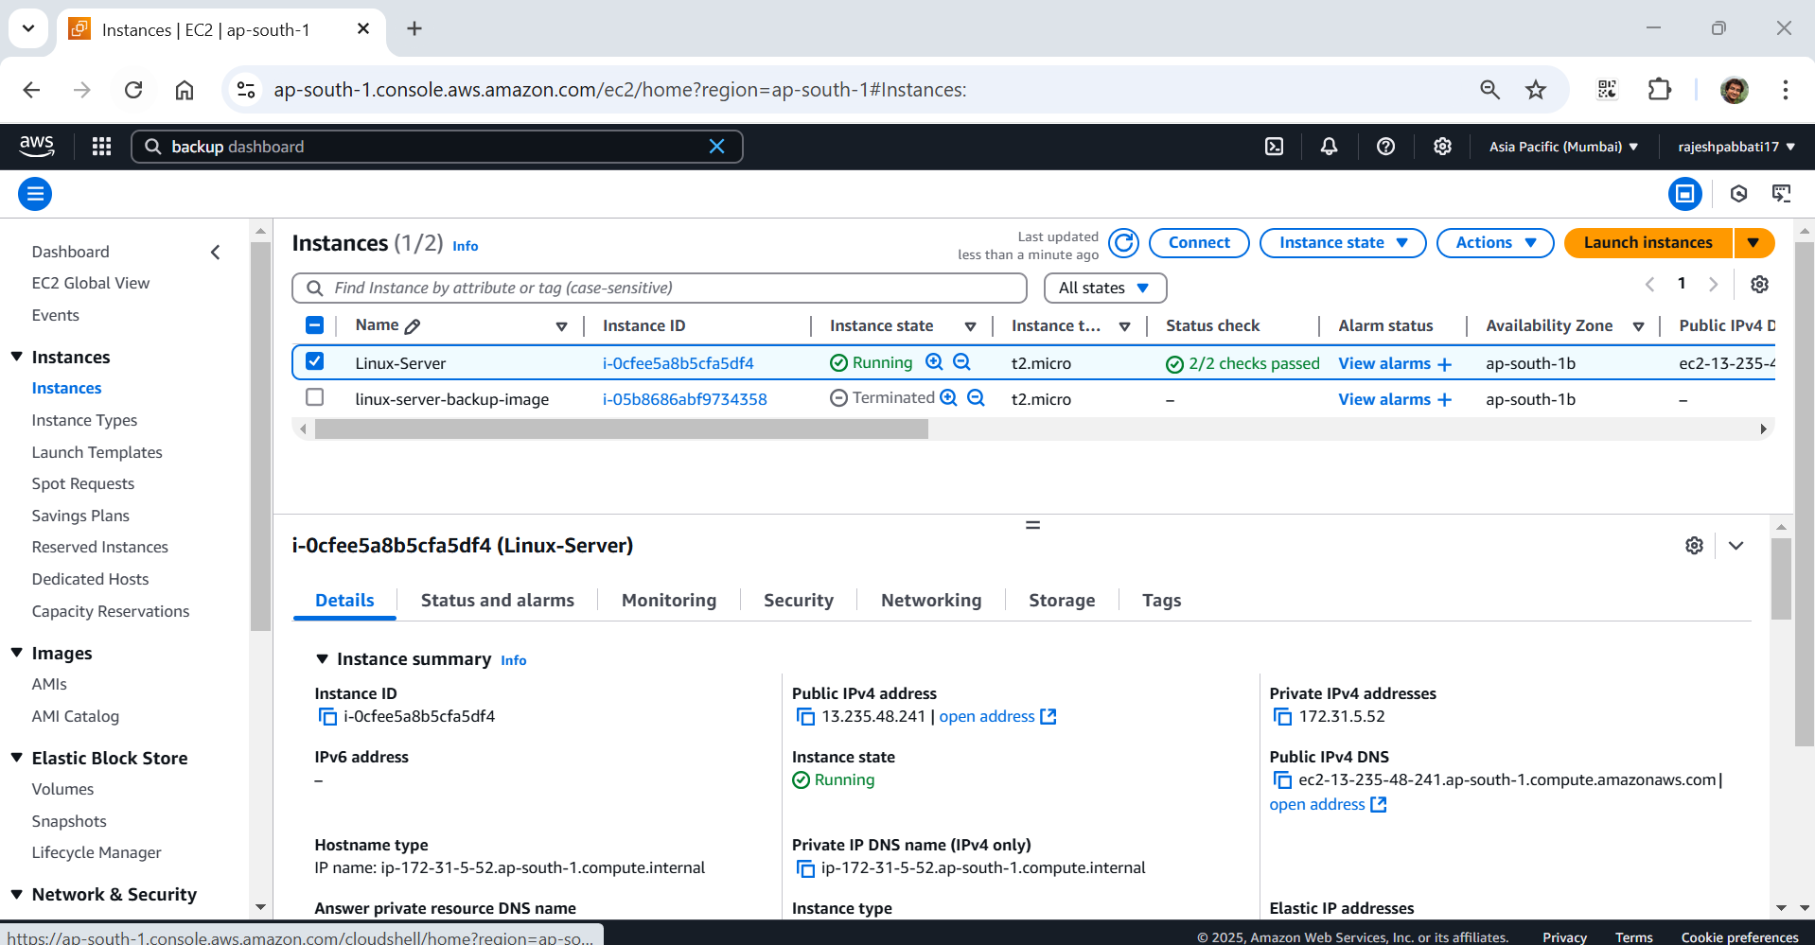

Click on connect

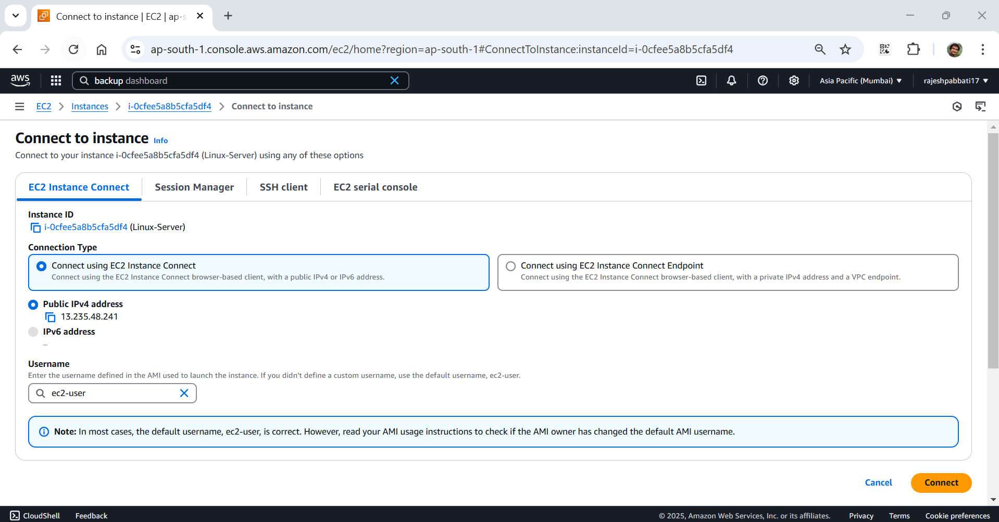

Run lsblk to check attached disks

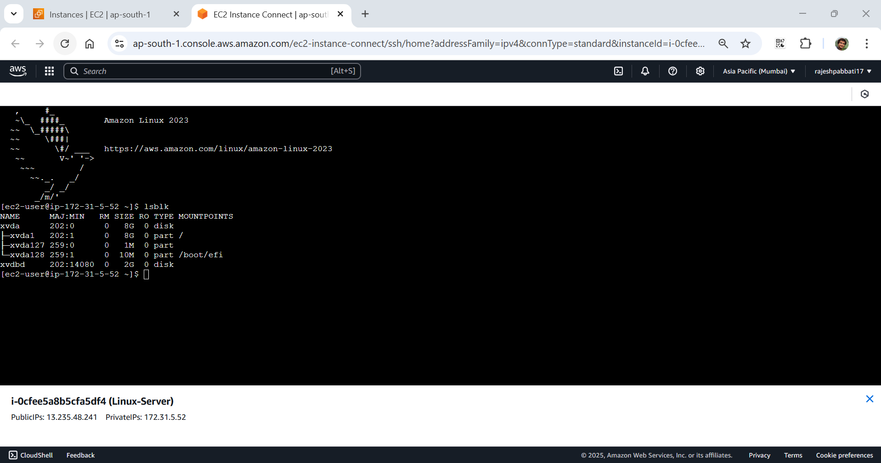

Check if the volume has any data using the following command. If the response shows /dev/svdbd: data it means volume is empty

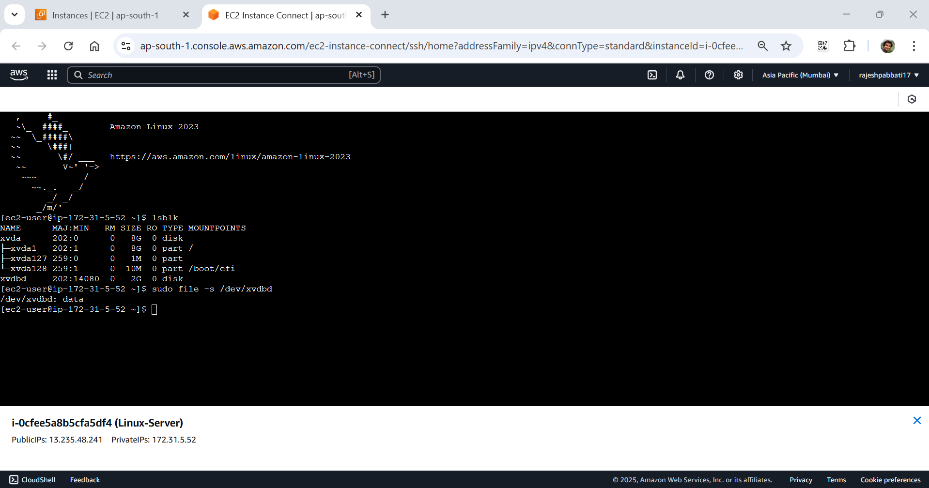

Format the volume to ext4 filesystem

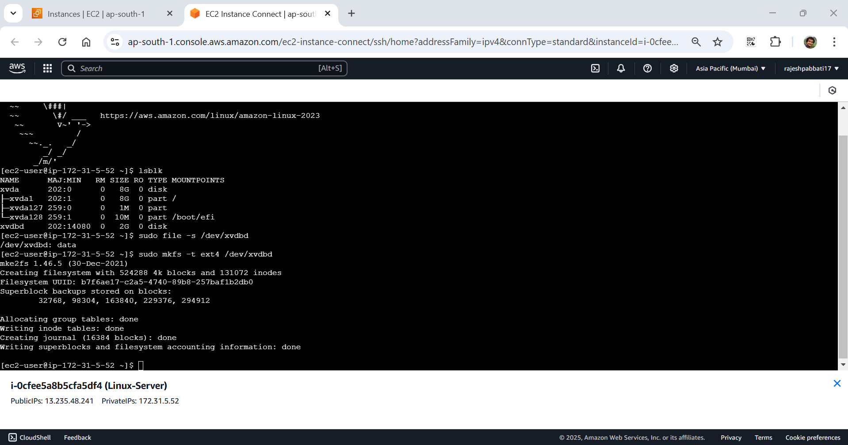

Create new folder to mount the filesystem

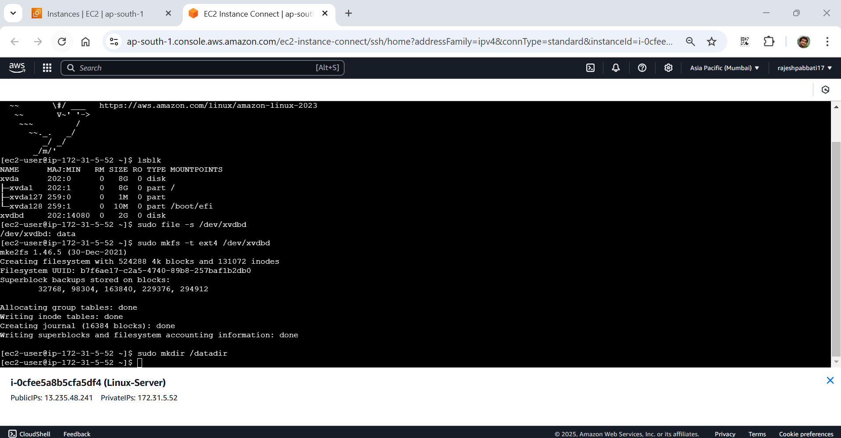

Mount the file system on the created filesystem

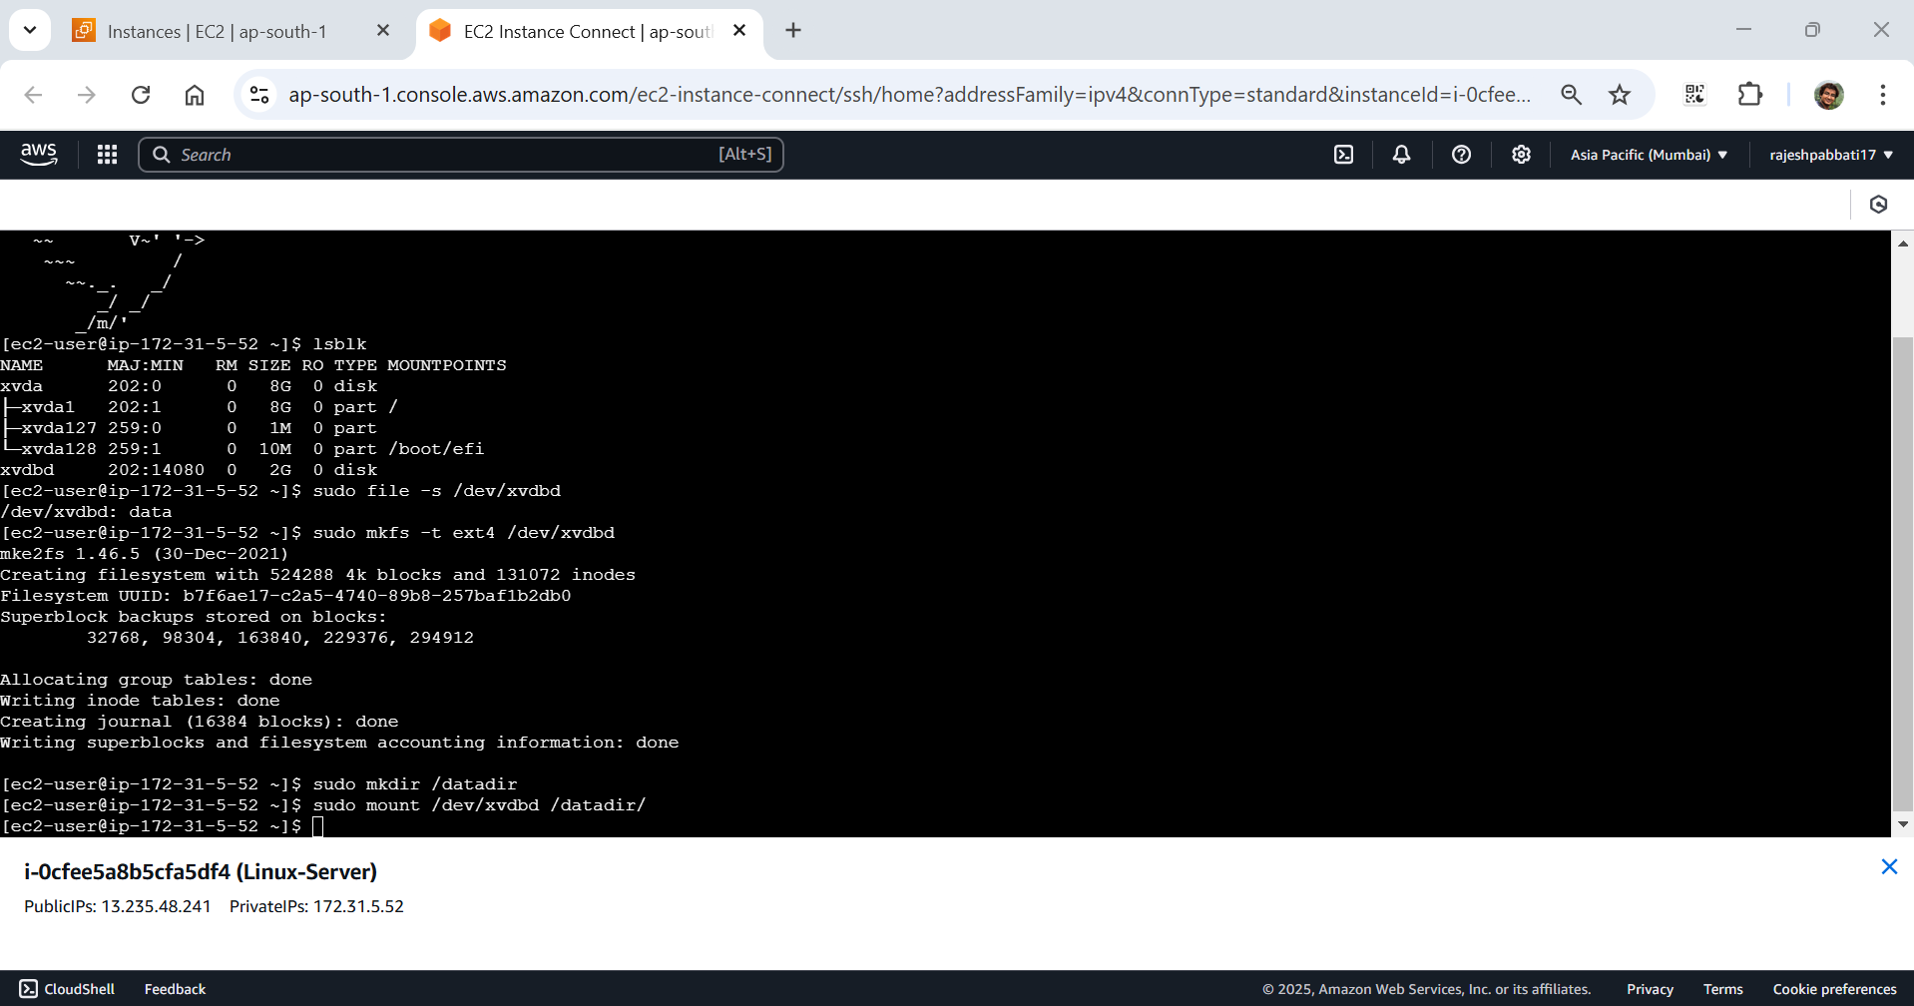

Confirm the disk mounted

Type lsblk to confirm if newly mounted volume is had mountpoint with /datadir

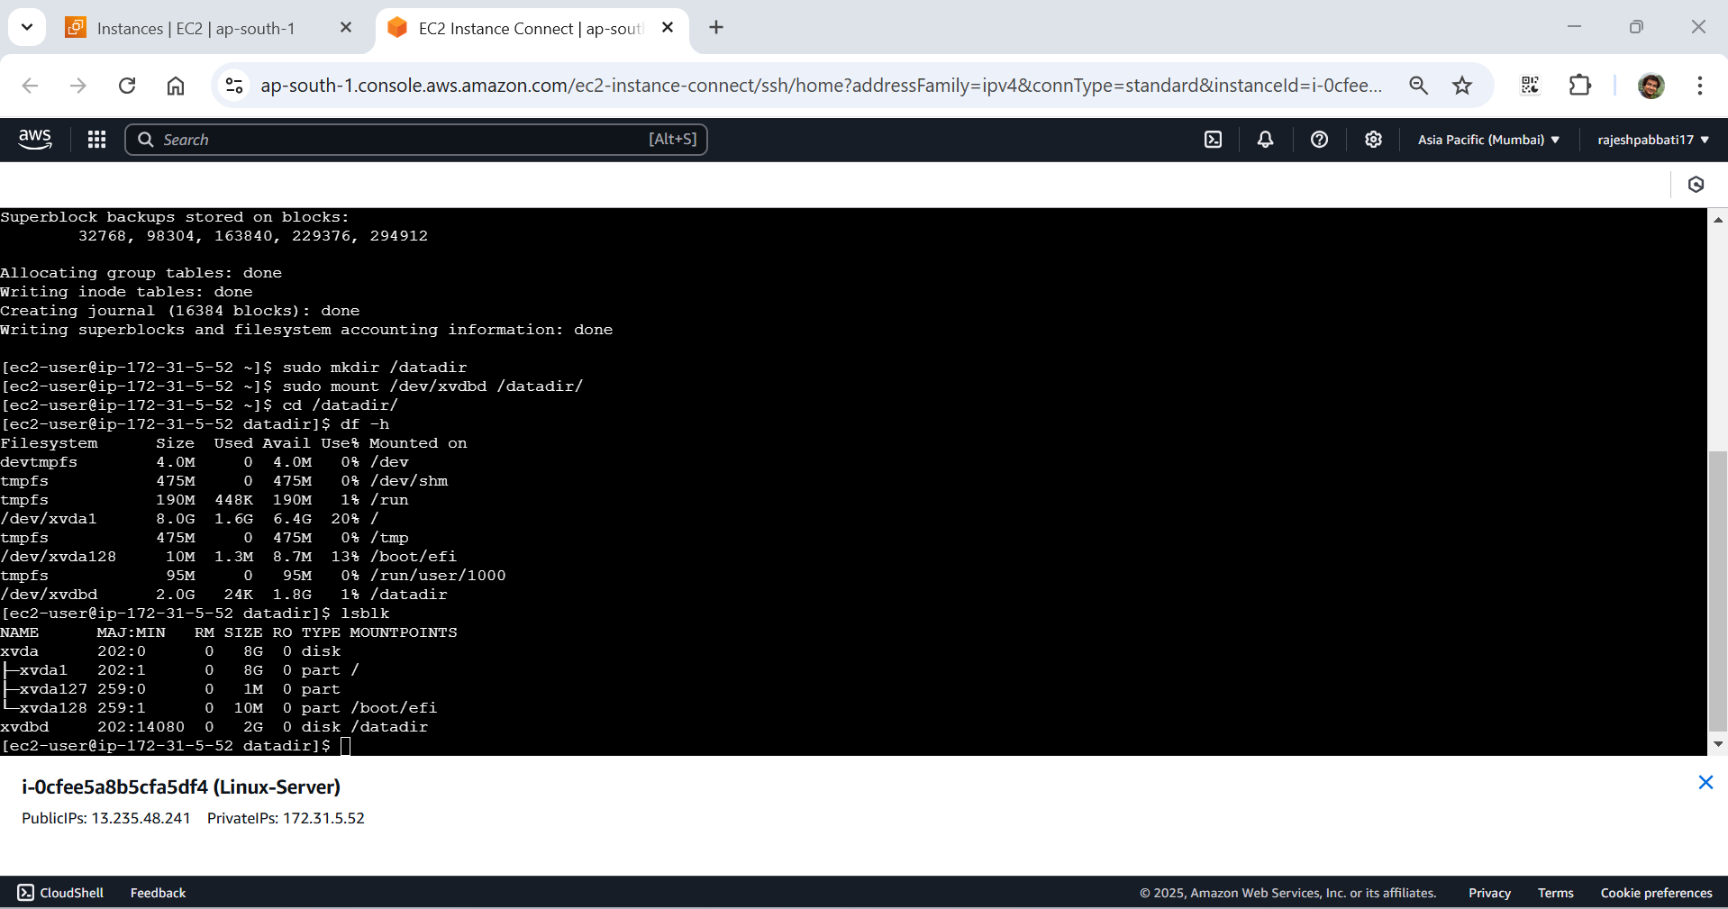

Select the volume and click on action -> create snapshot

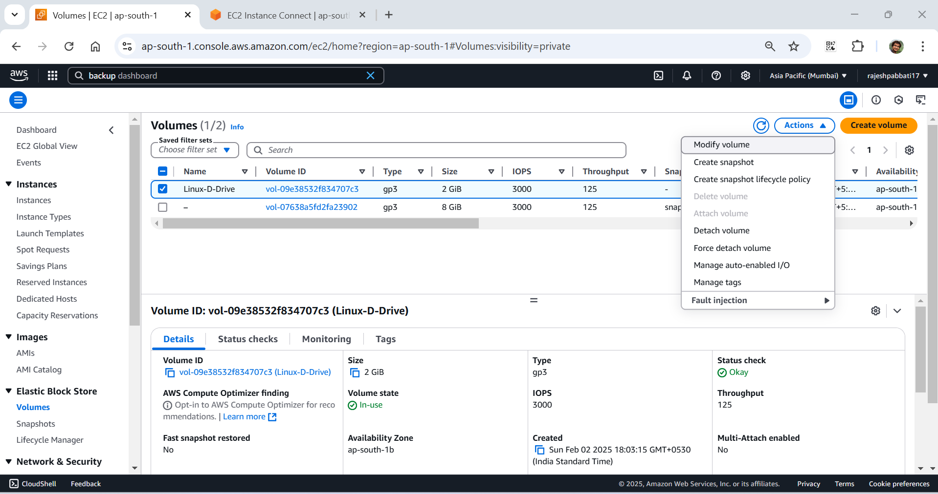

Give description and click on create snapshot

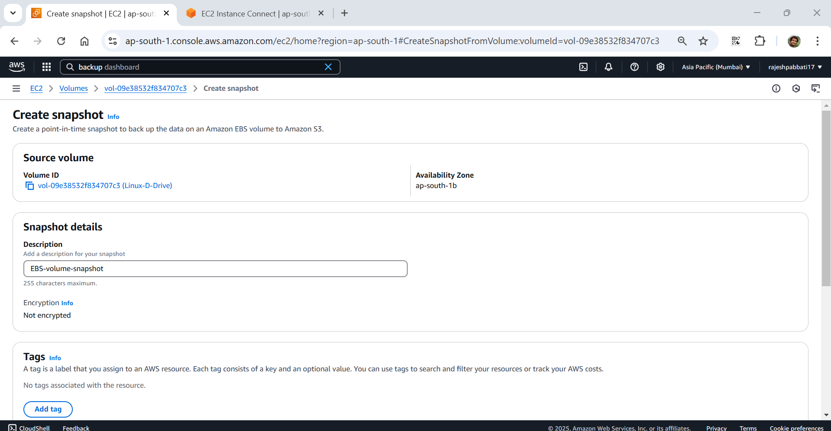

Select the snapshot click on action -> copy snapshot

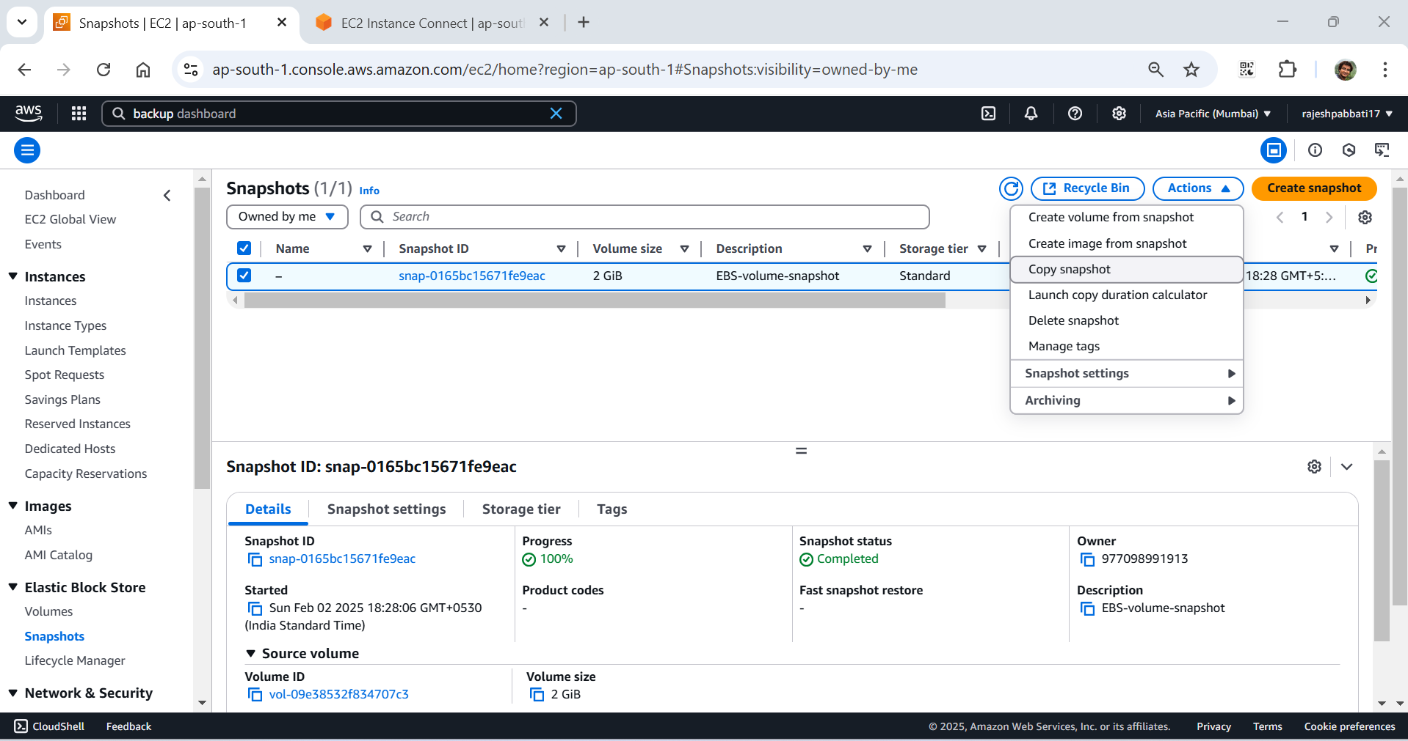

Click on copy snapshot

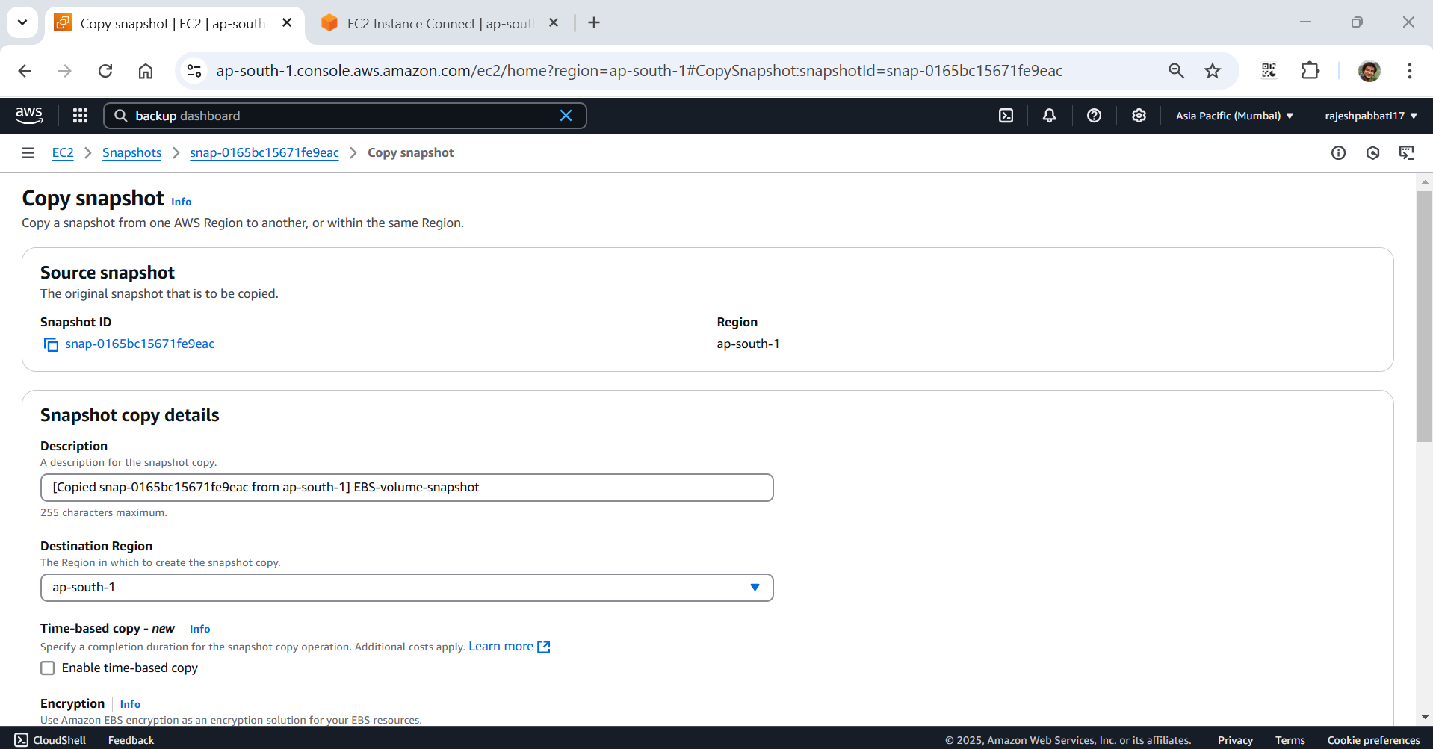

Copied snapshot is created

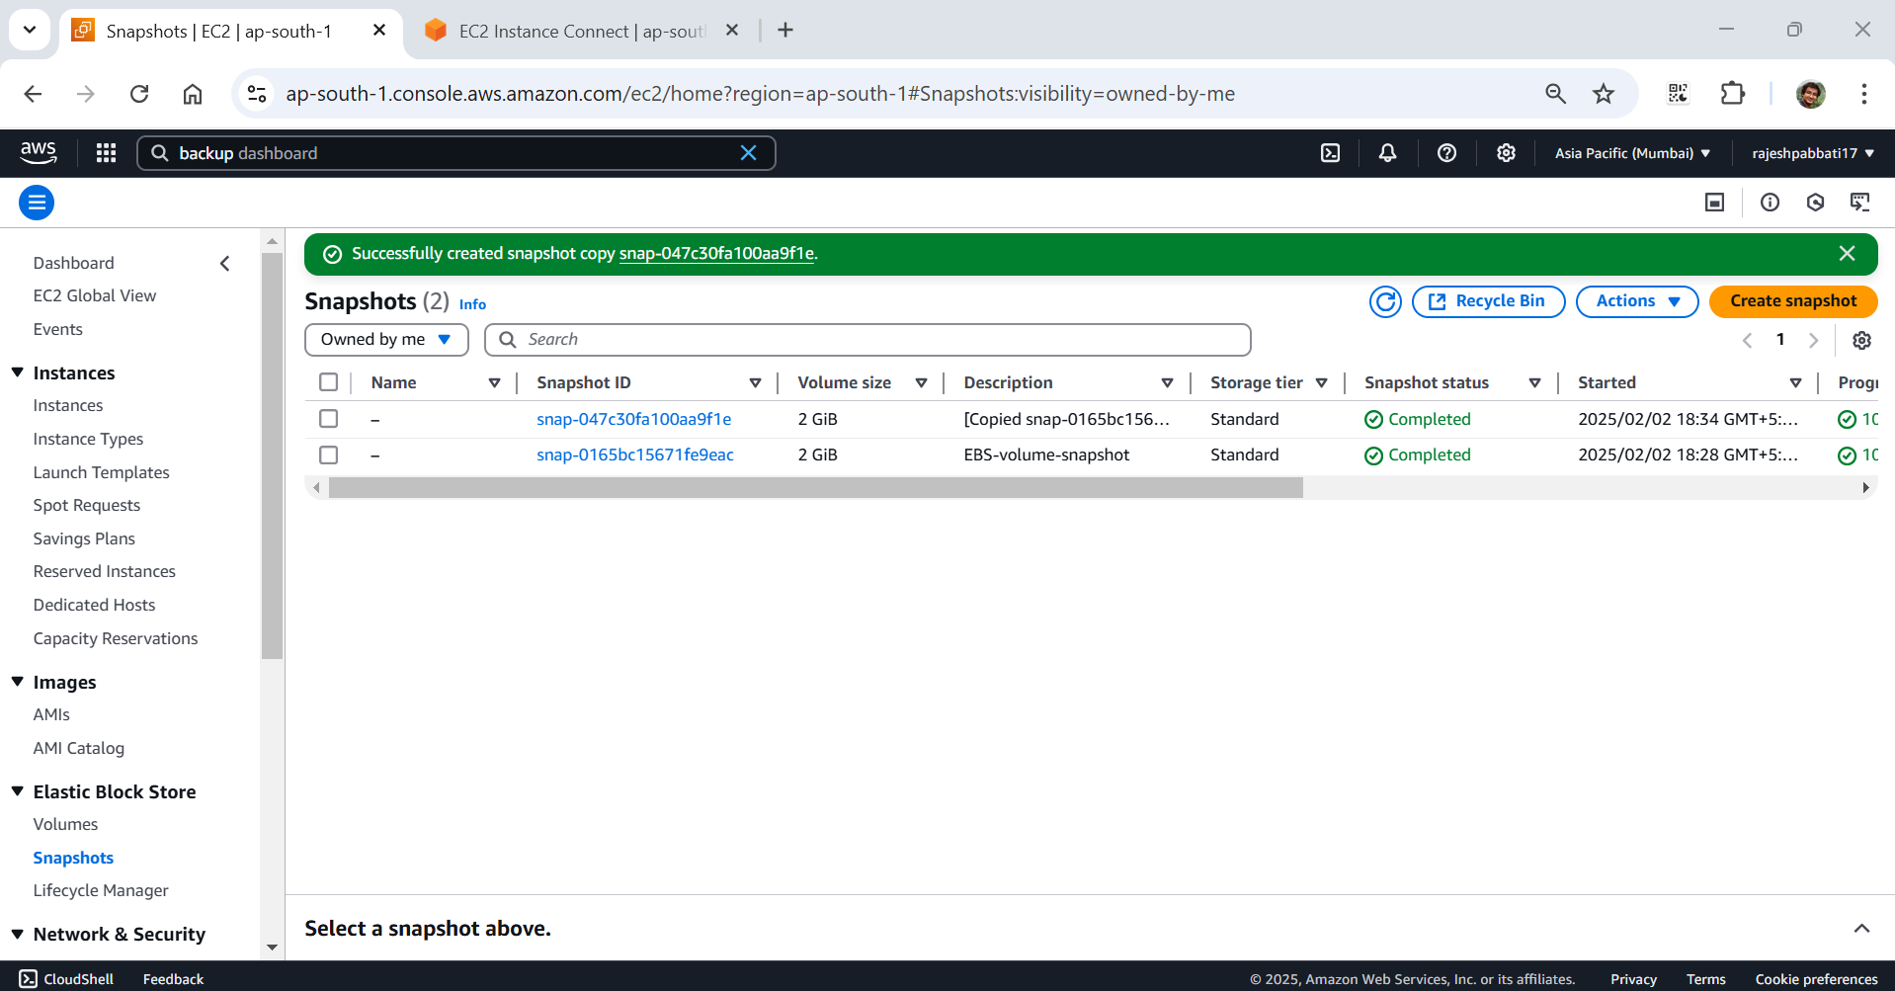

Select the copied snapshot click on actions -> create volume from snapshot

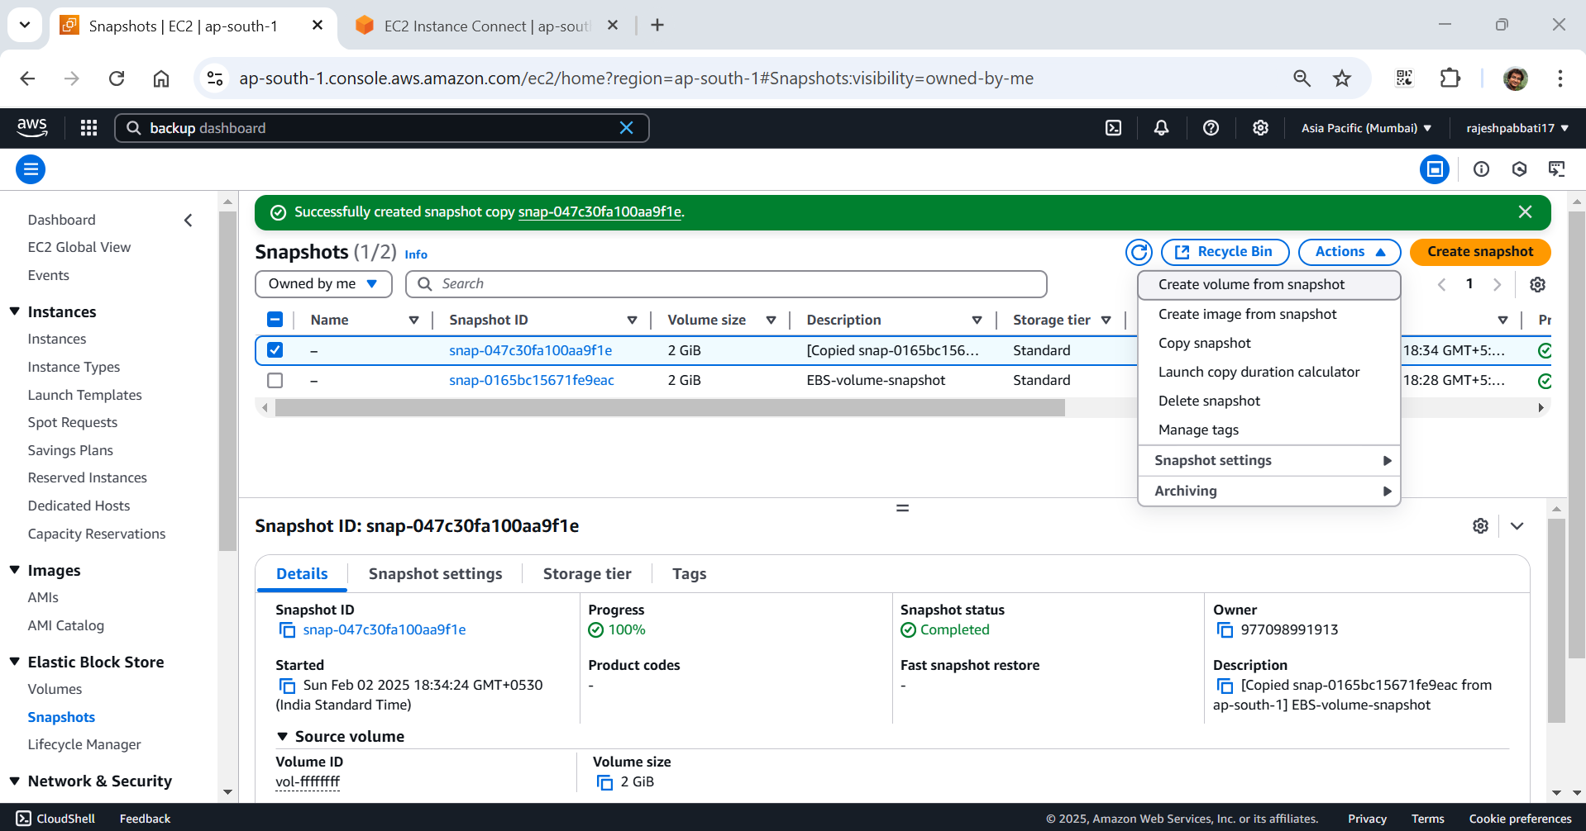

Select different availability zone and click on create volume

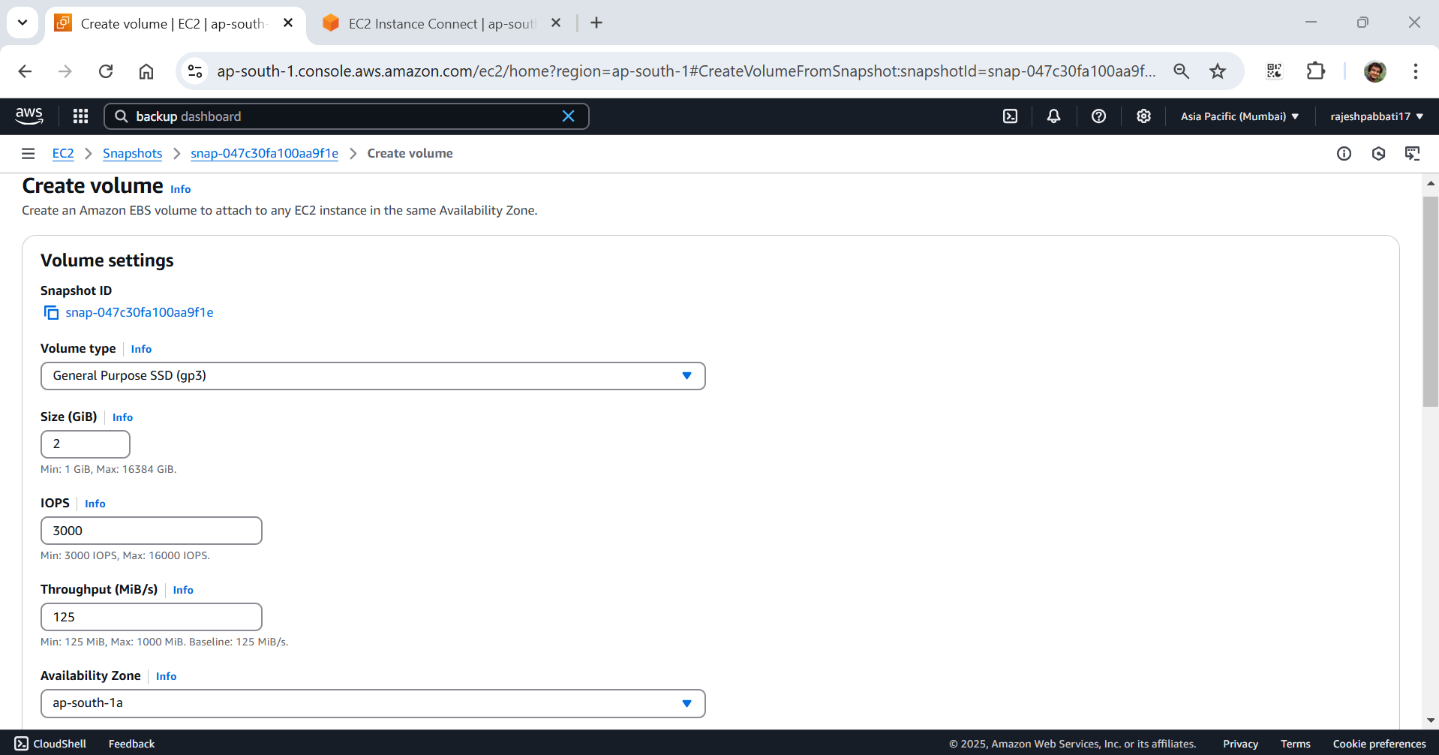

New EBS volume Is created

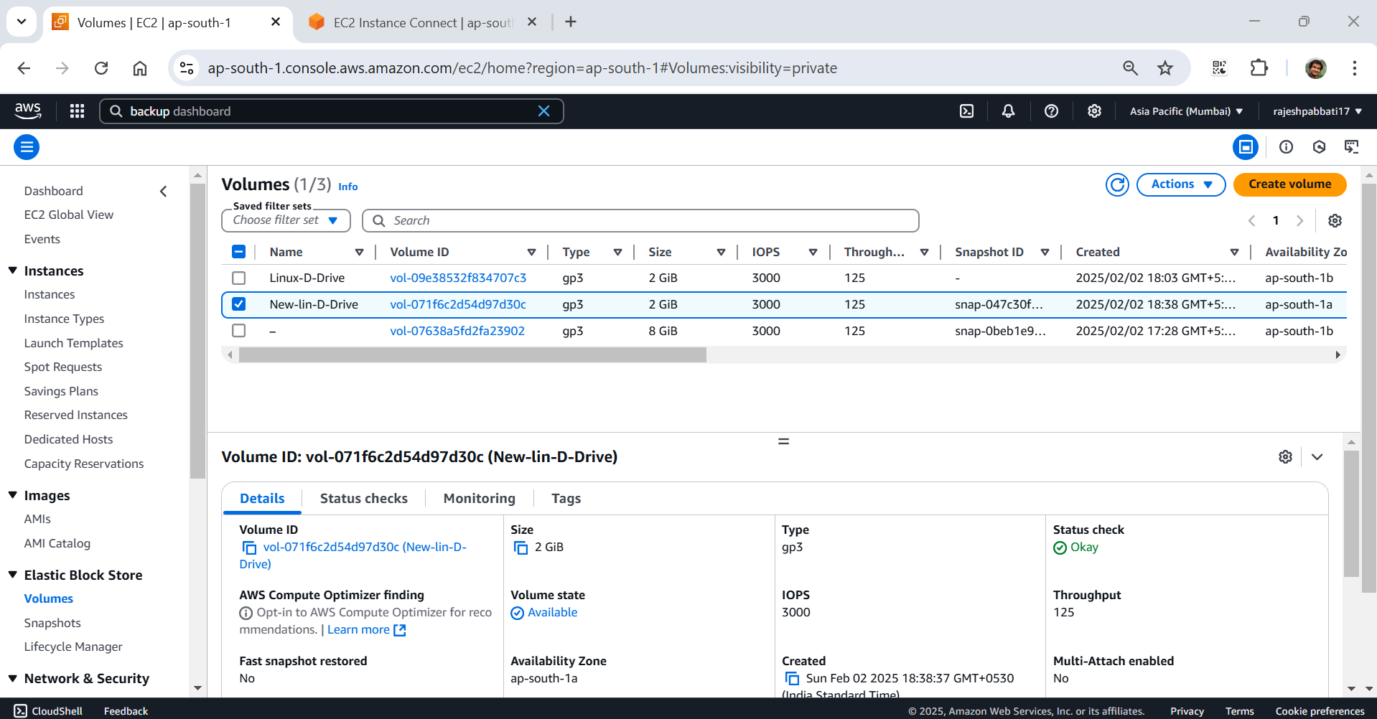

Launch new instance

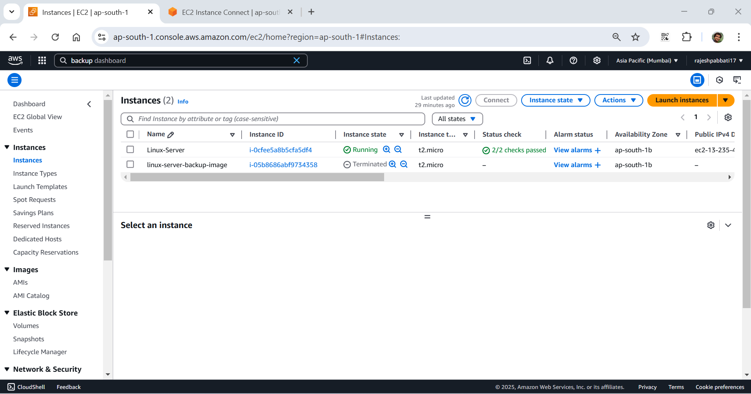

Give name

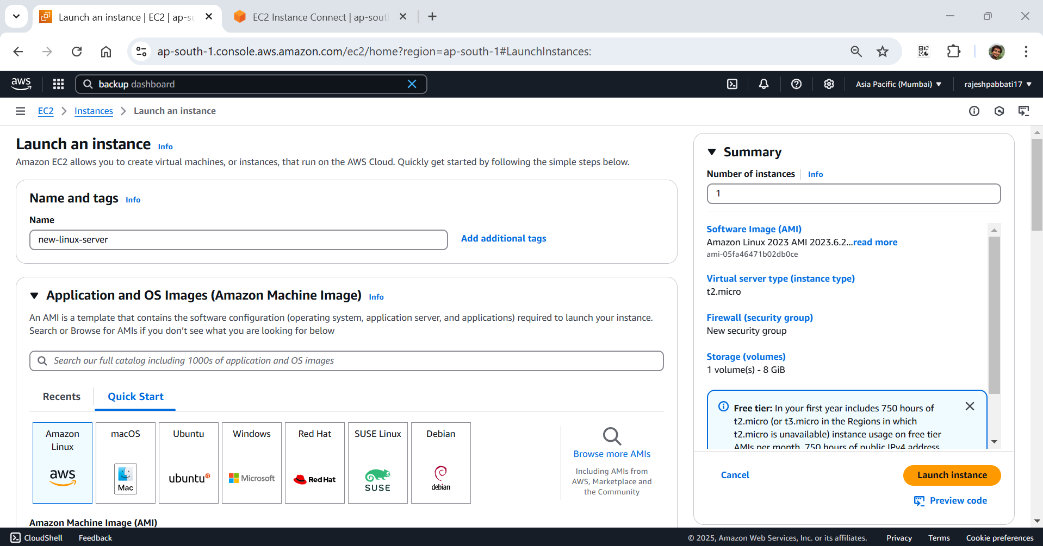

Select key pair, default vpc, and subnet availability zone same as EBS availability zone and security group linux-SG and launch instance

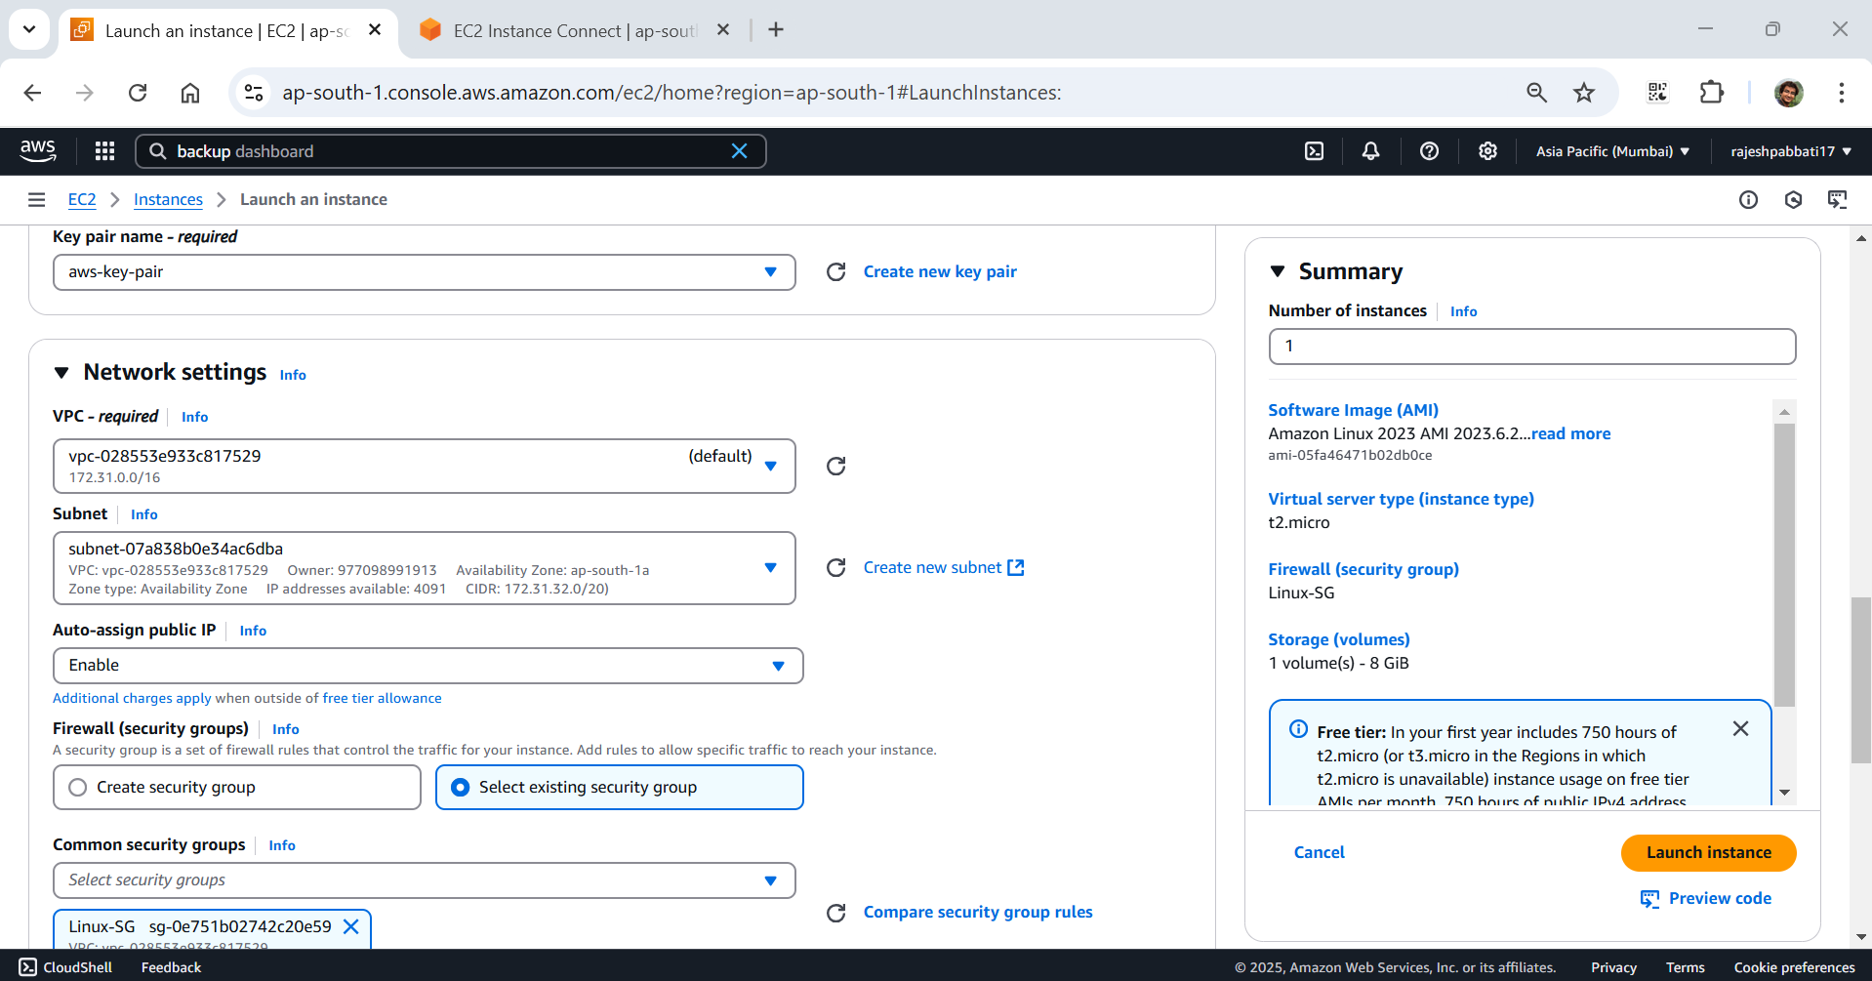

Instance launched and click on volumes

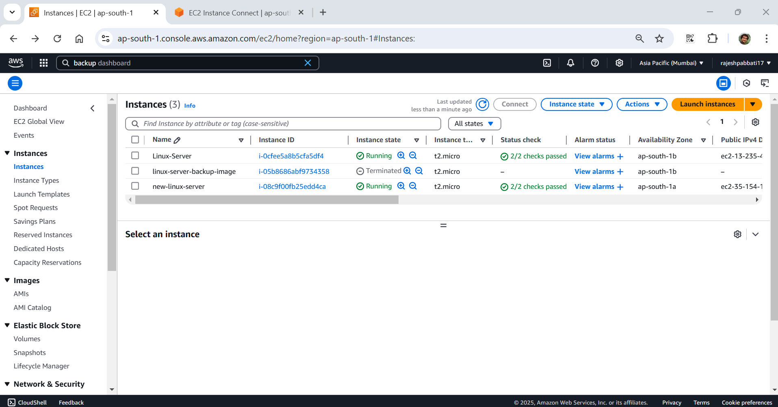

Select the new EBS volume and click on Actions -> Attach volume

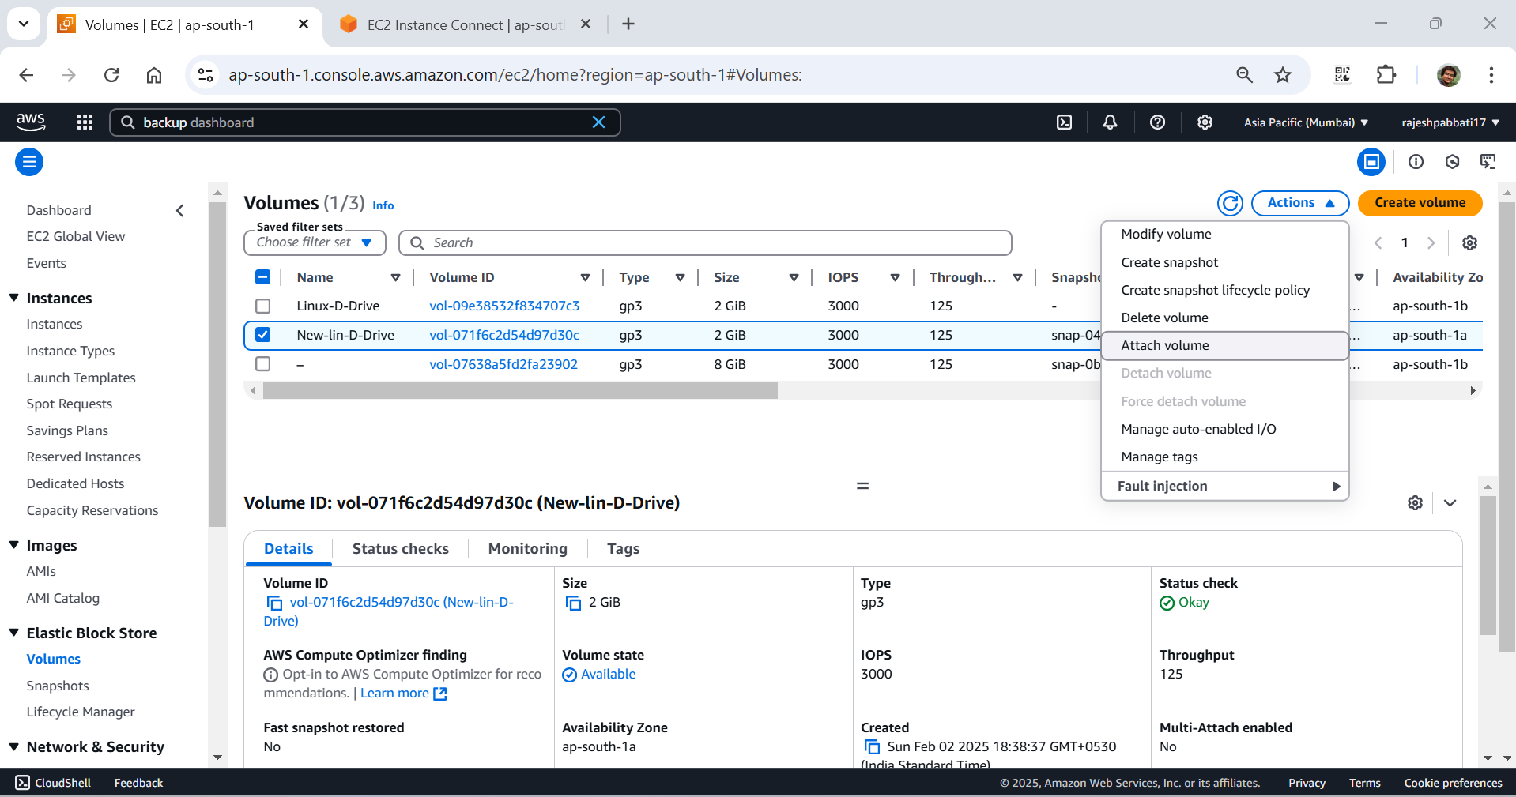

Select instance, device name and click on Attach volume

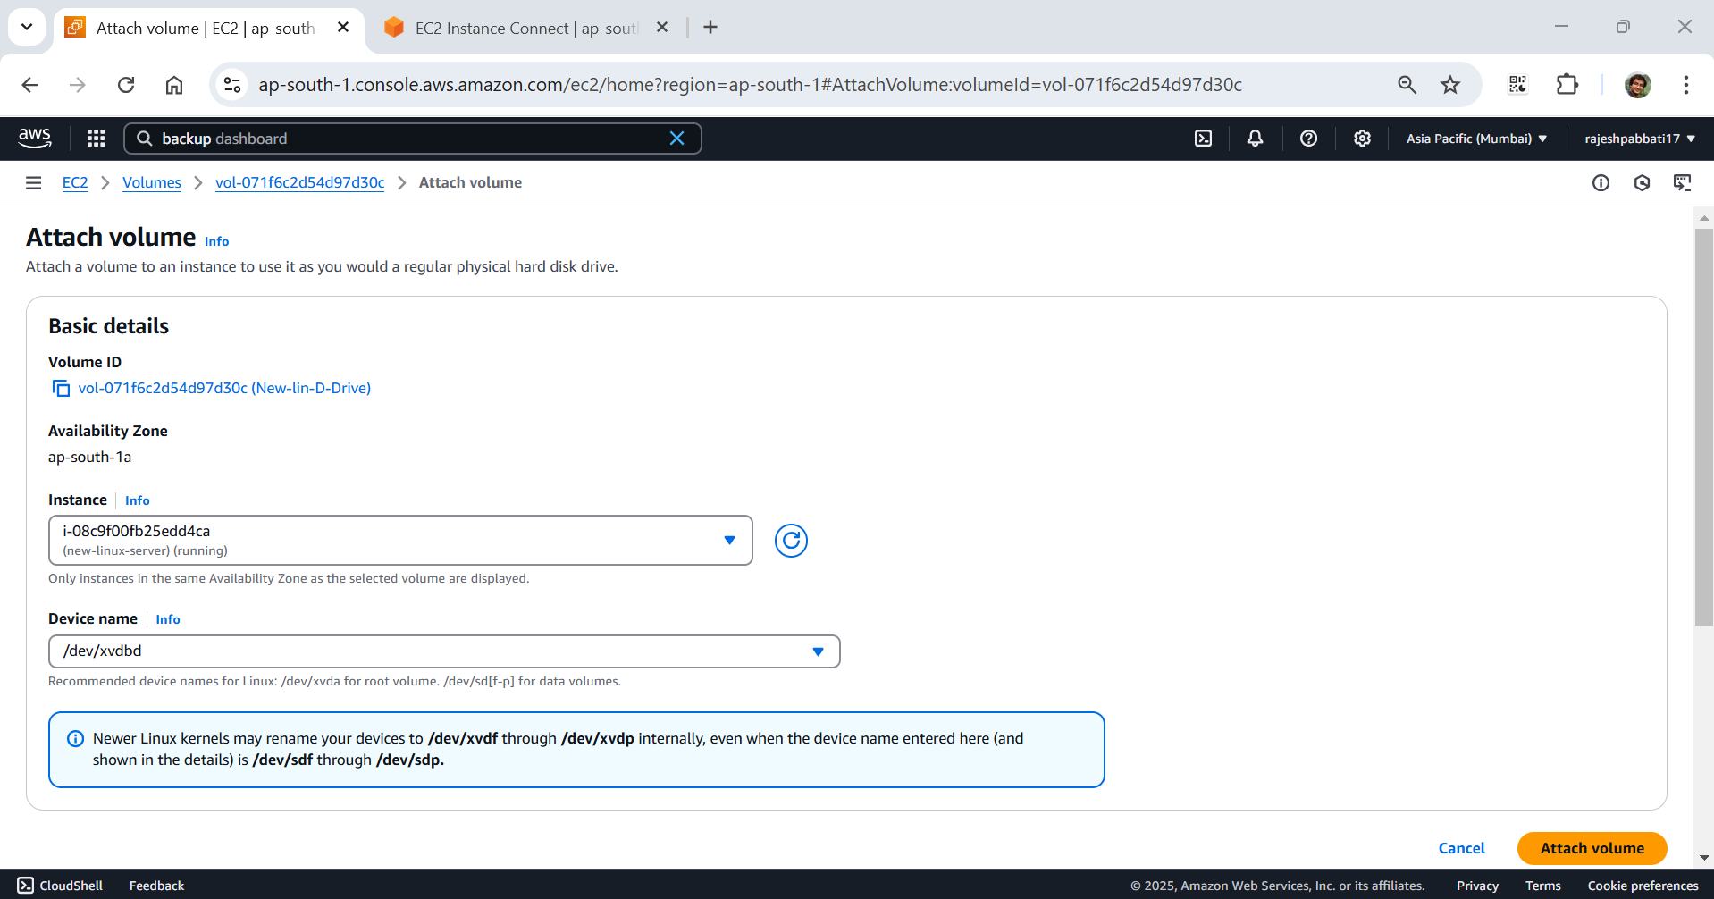

Select the new instance and click on connect

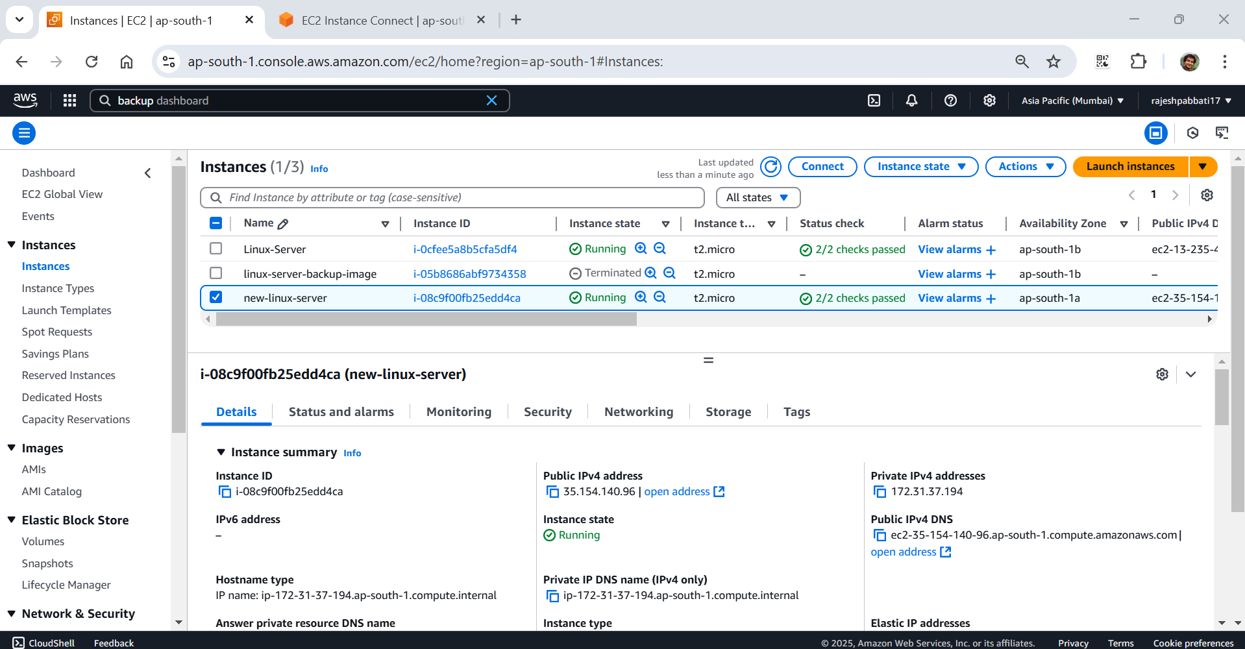

Click on connect

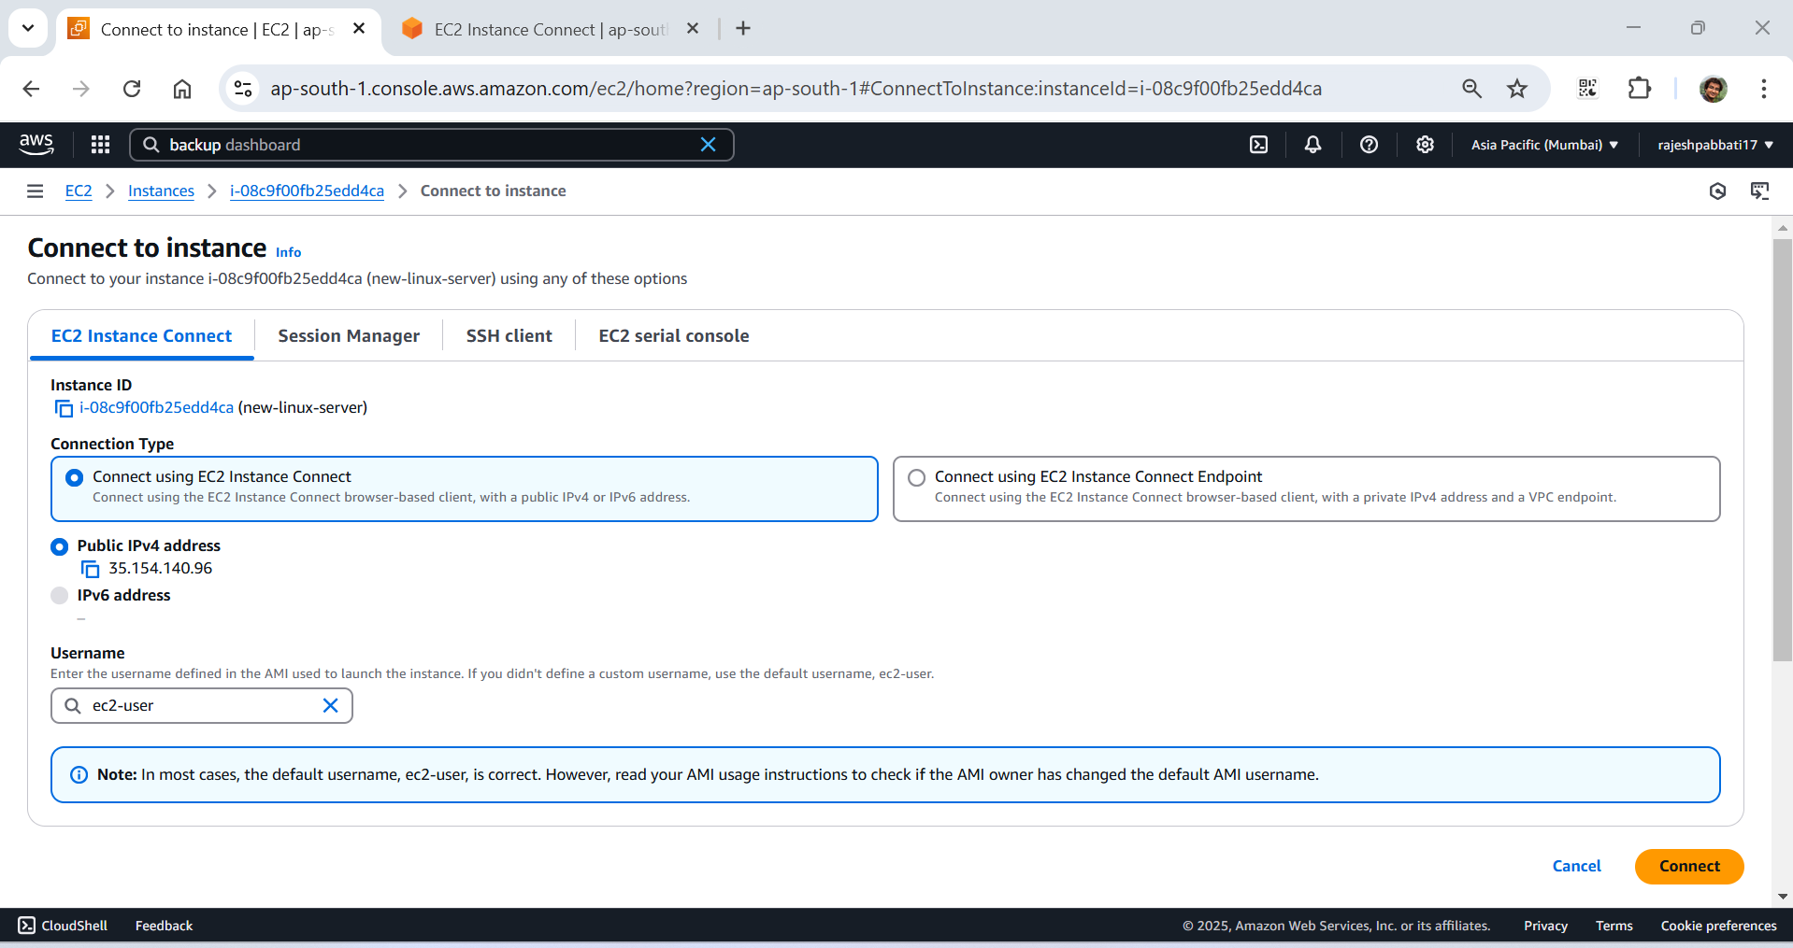

Run lsblk to check attached disks

Check if the volume has any data. If the response is /dev/xvdbd: data then empty but this is volume created from snapshot so having some data from previous server.

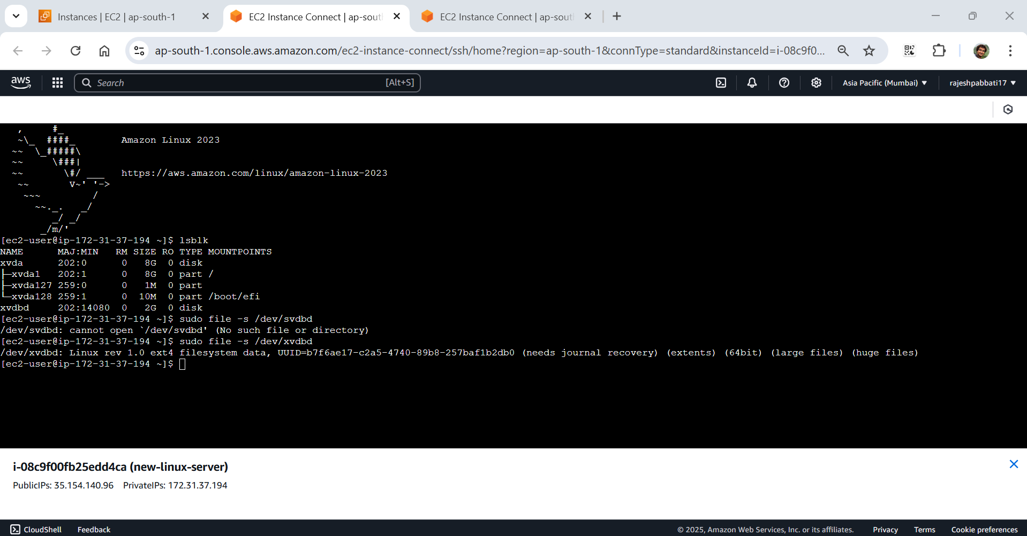

Format the volume to ext4 filesystem

Create new folder to mount the filesystem

Mount the filesystem on the created directory the change to directory to /datadir/

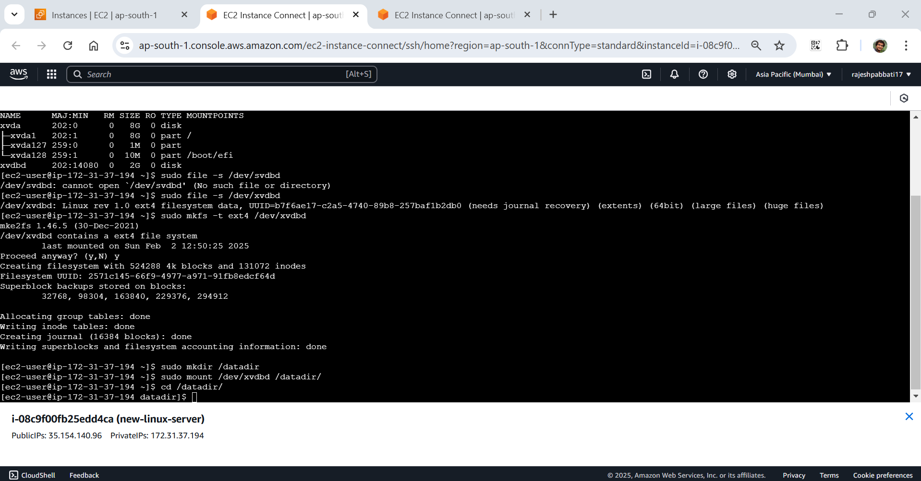

Confirm the disk mounted

Type lsblk to confirm if newly mounted volume is had mountpoint with /datadir

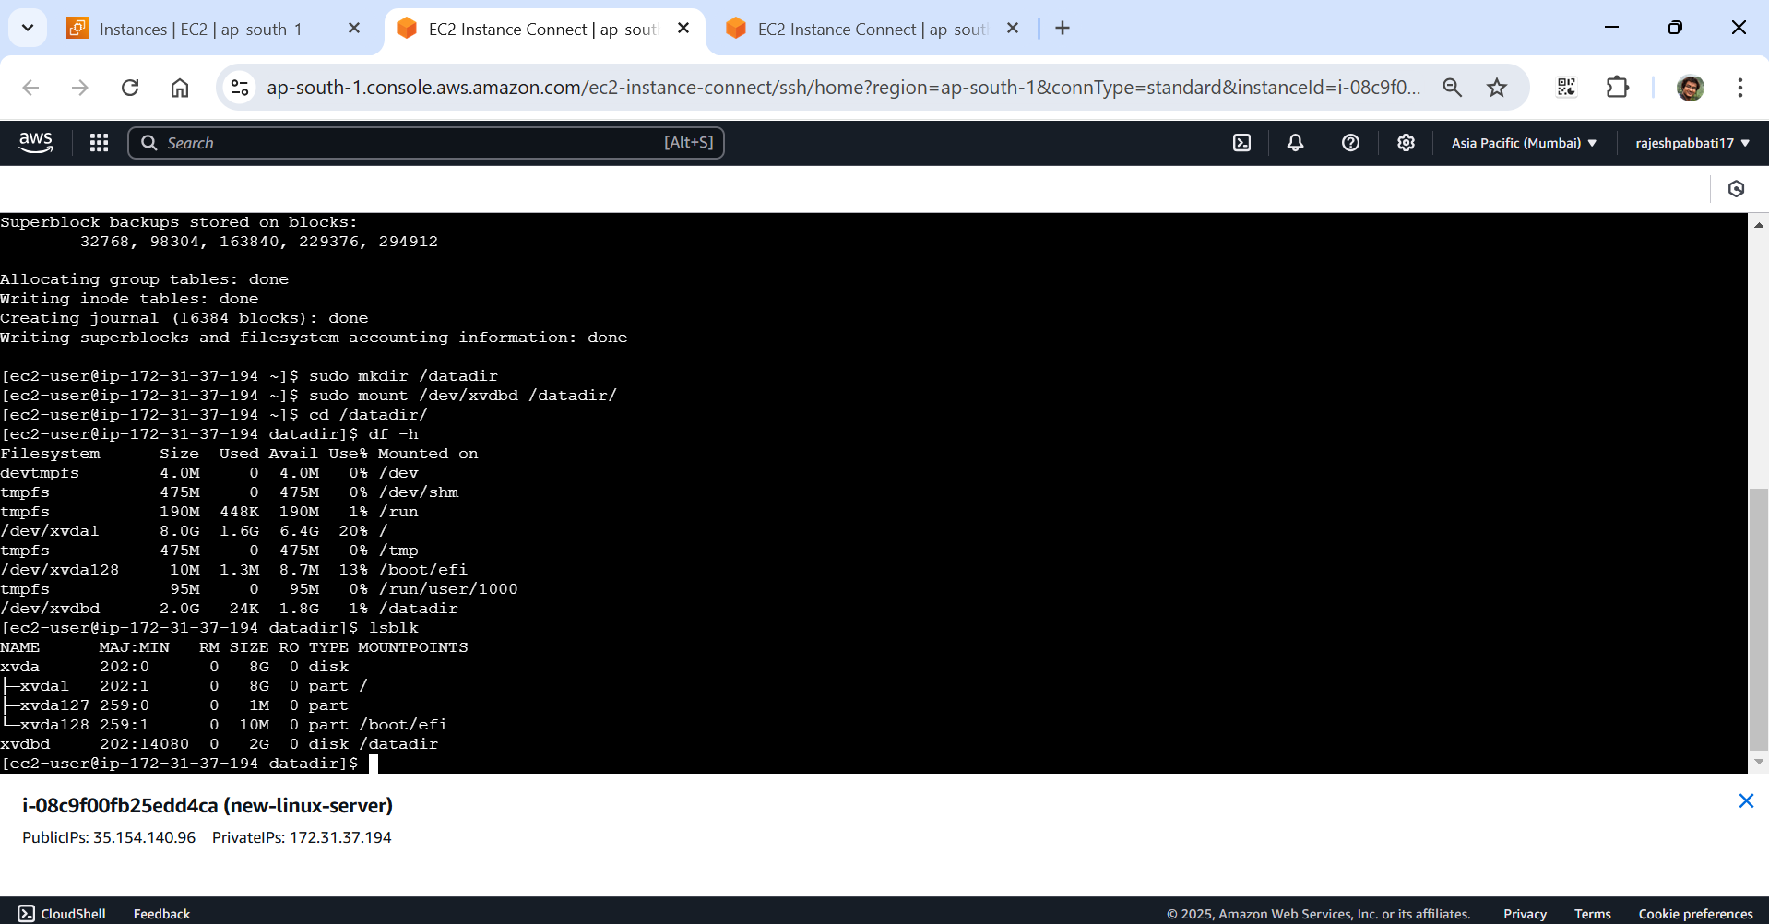

Assignment 2

Go to AMIs which is created in assignment 1, select and click on Launch Instance from AMI

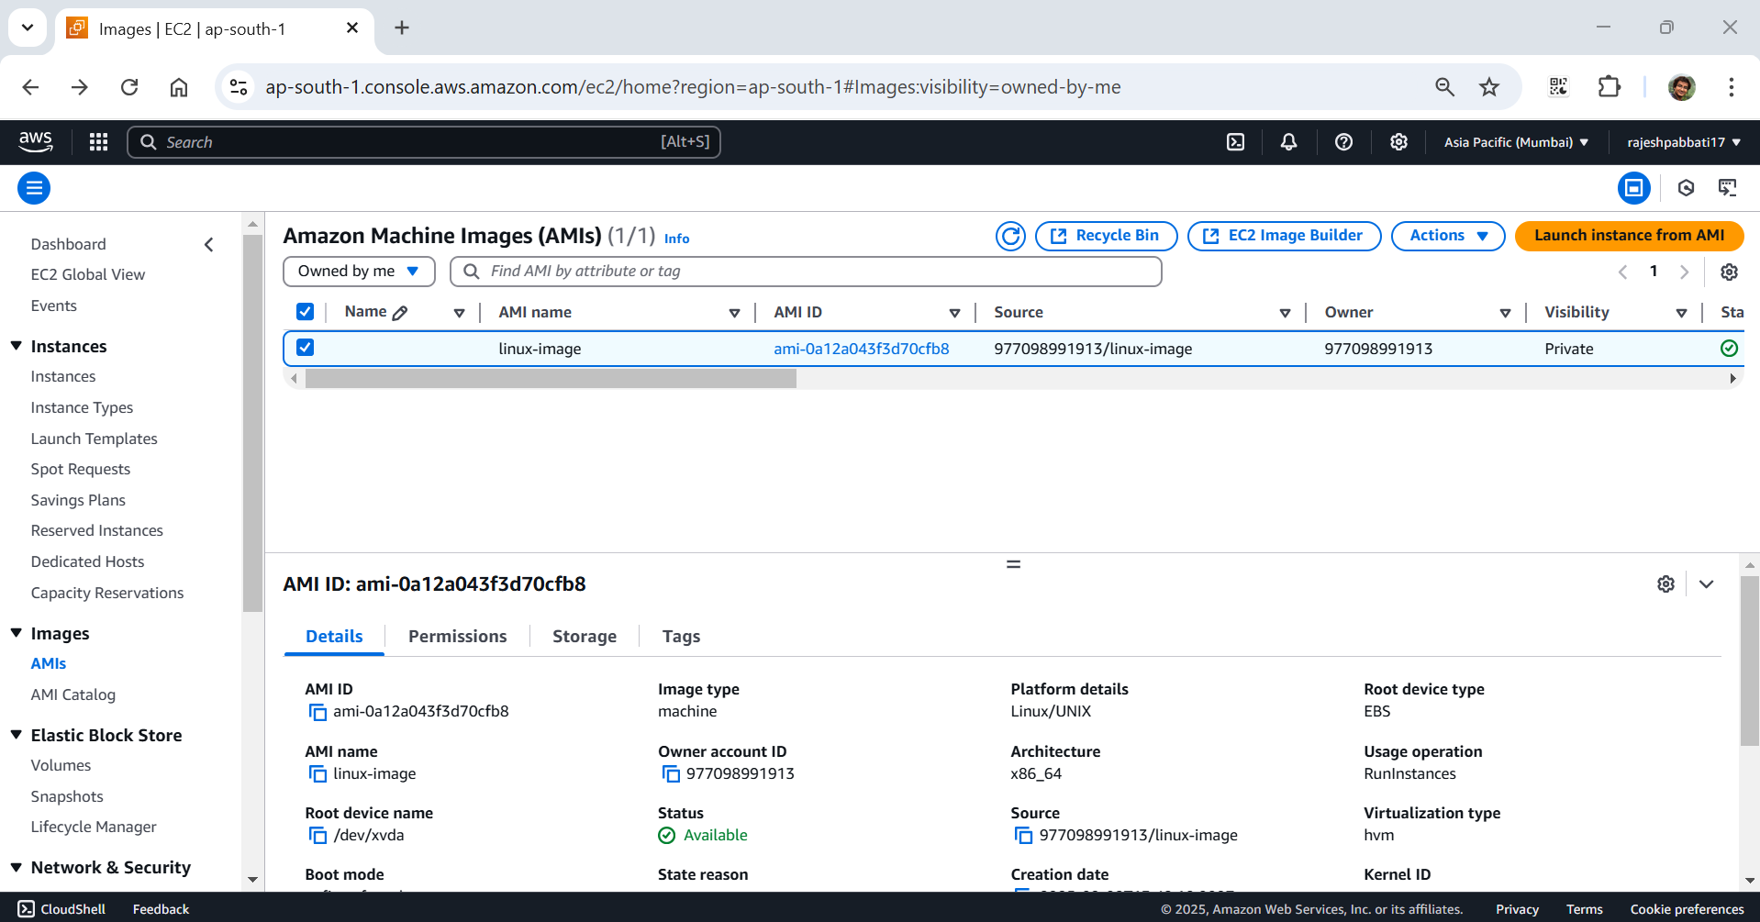

Give the name

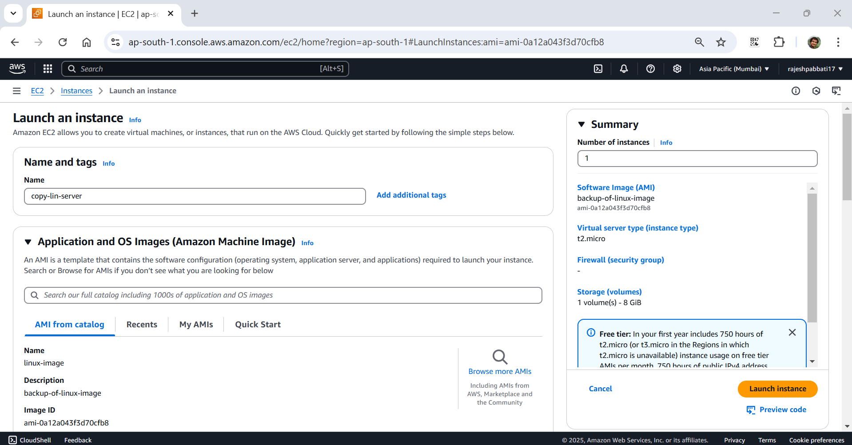

Select key pair, default VPC, subnet in different availability zone of existing server, select security group linux-SG and click on launch instance

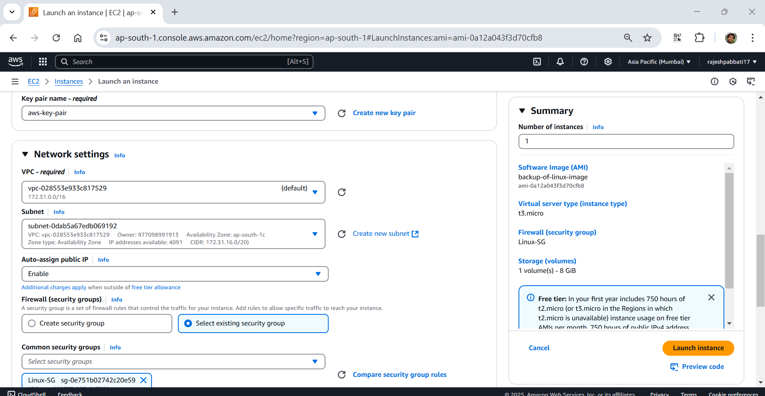

Assignment 3

Navigate Compute -> Elastic Beanstalk

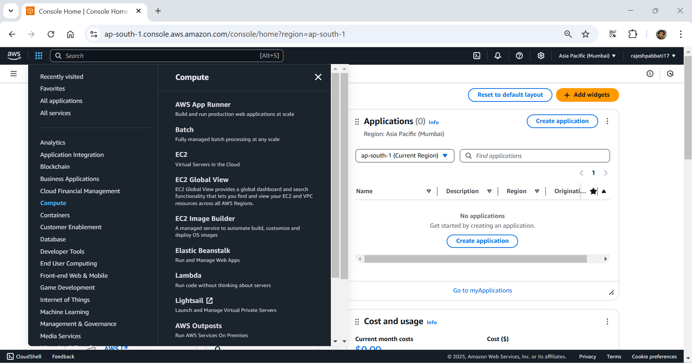

Click on create application

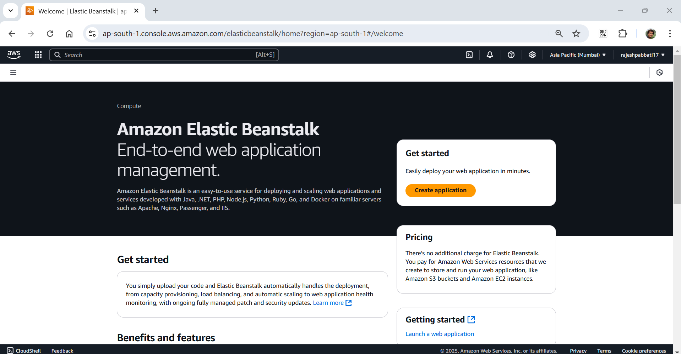

Give application name

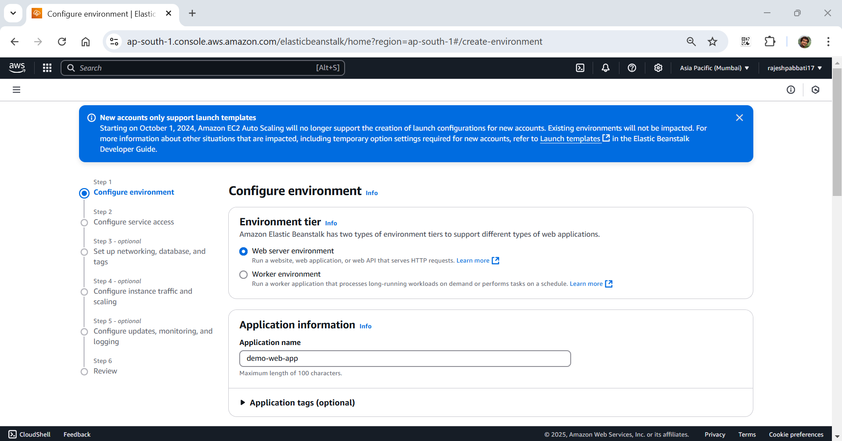

Select platform application code sample application

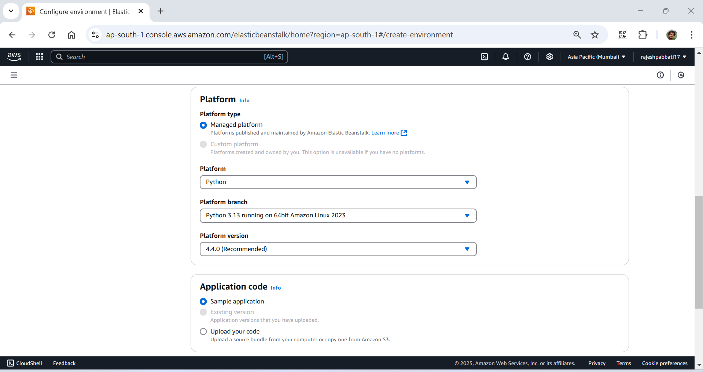

Click on next

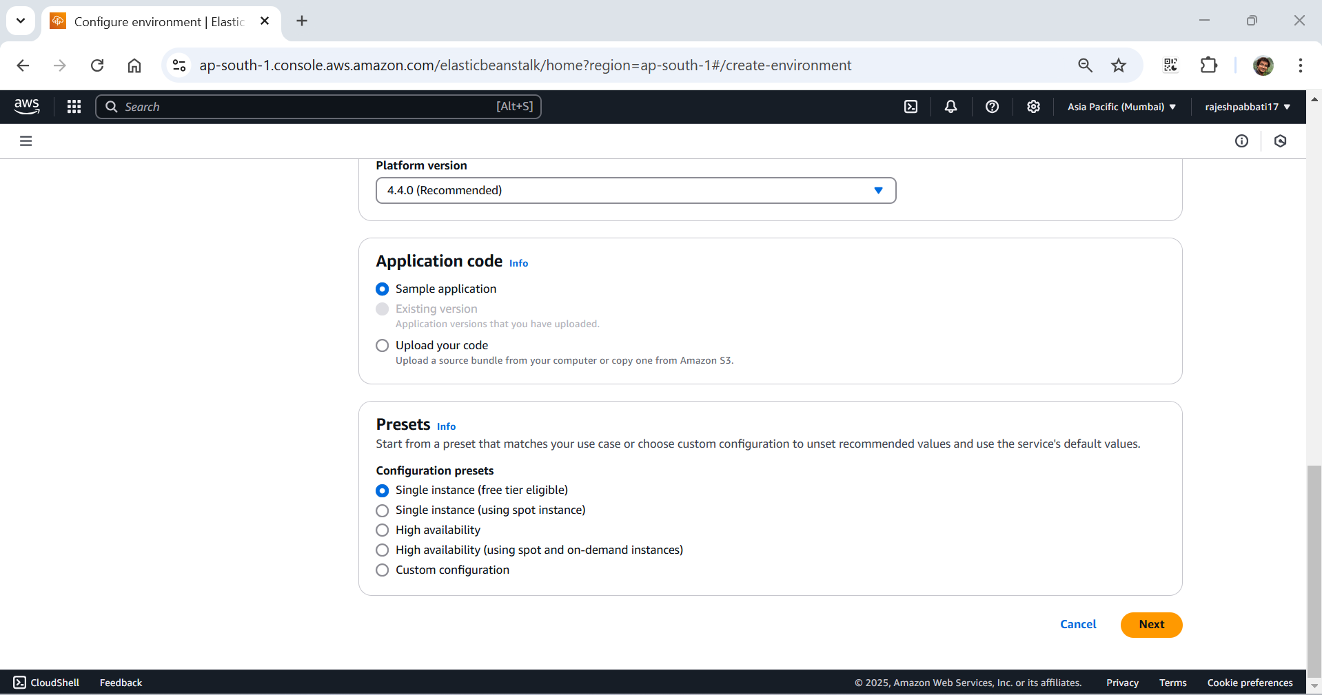

Already created EC2 instance profile from AIM by giving the permissions which are shown under EC2 instance profile -> View permission details. So, selecting Service role Use an existing service role. If not select Create and use new service role and create EC2 instance profile. Select EC2 key pair and click on next.

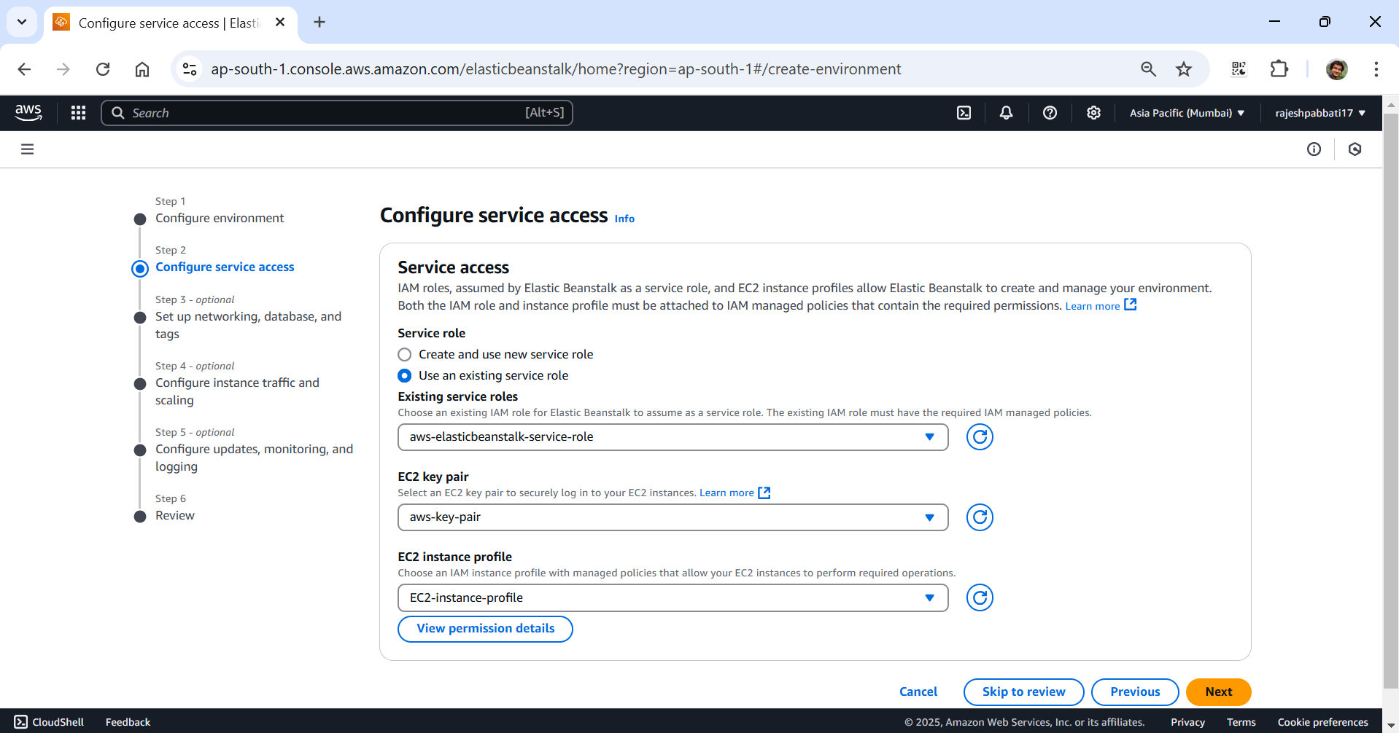

Select default VPC

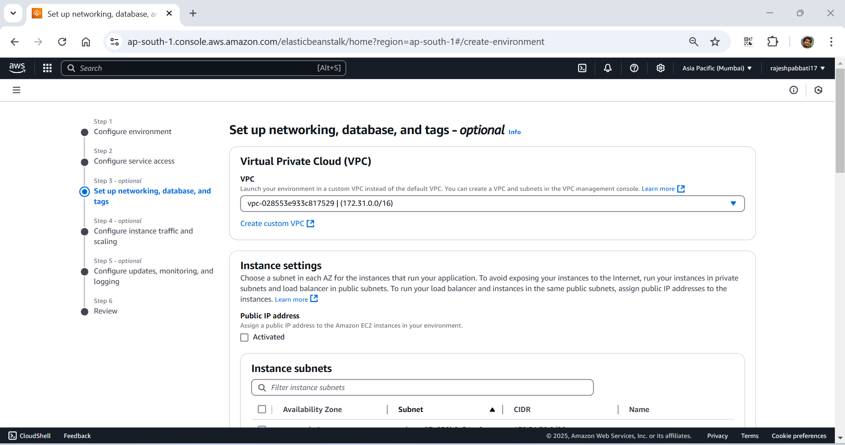

Select all instance subnets and click next

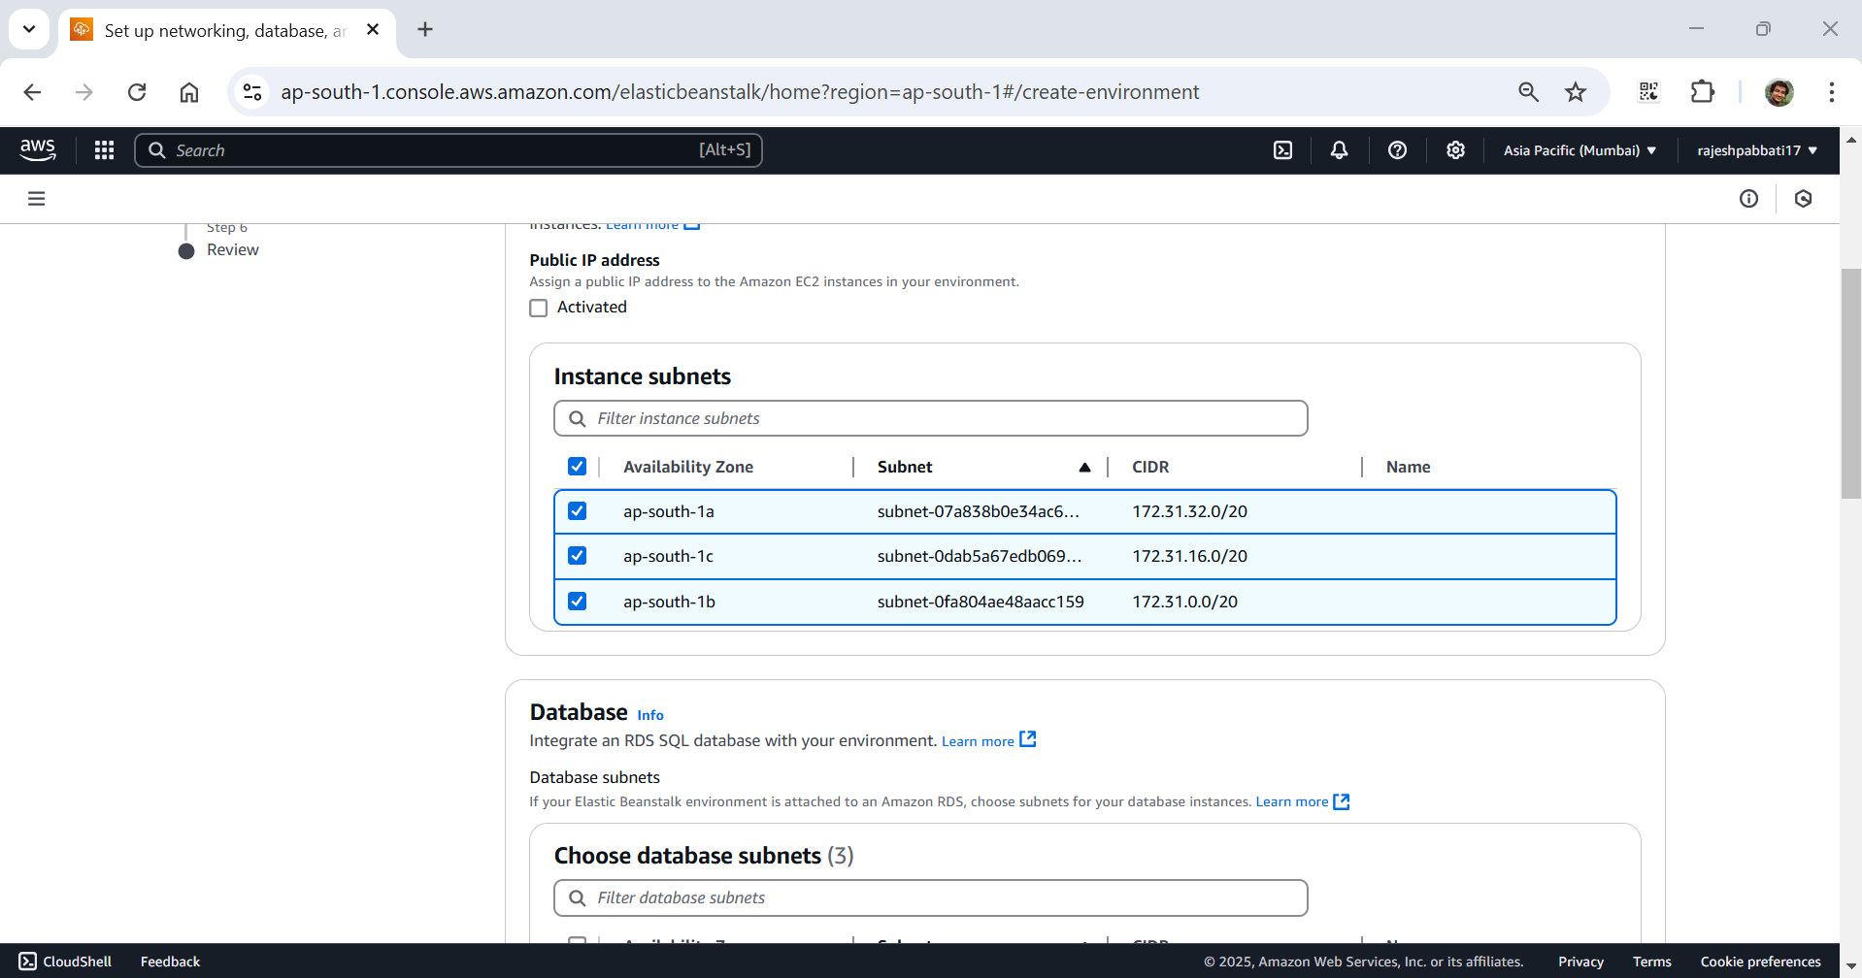

Select EC2 security groups default and Linux-SG and click next

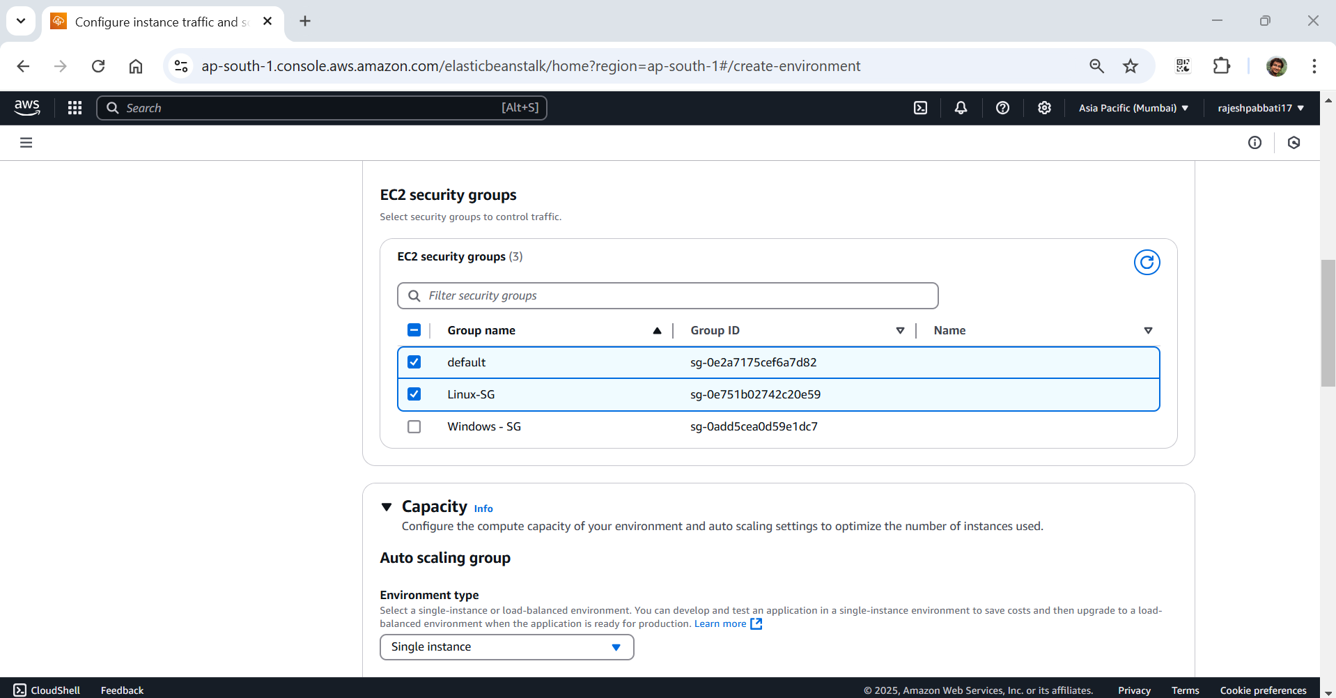

Select System Basic

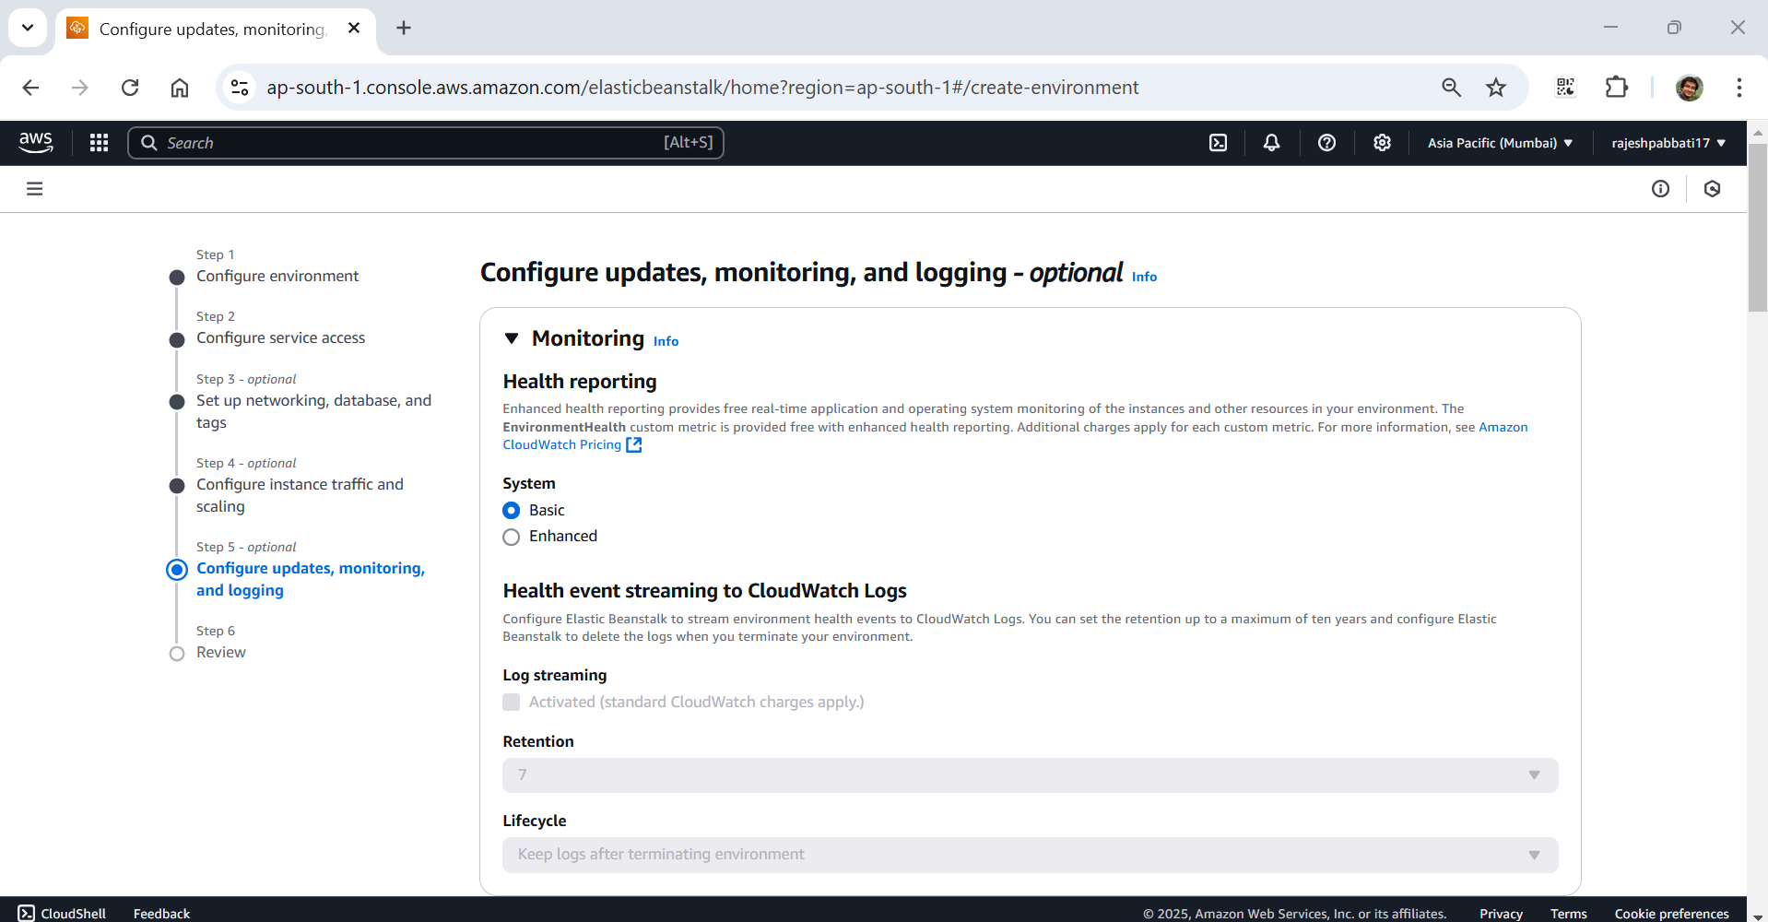

Uncheck managed updates and click next

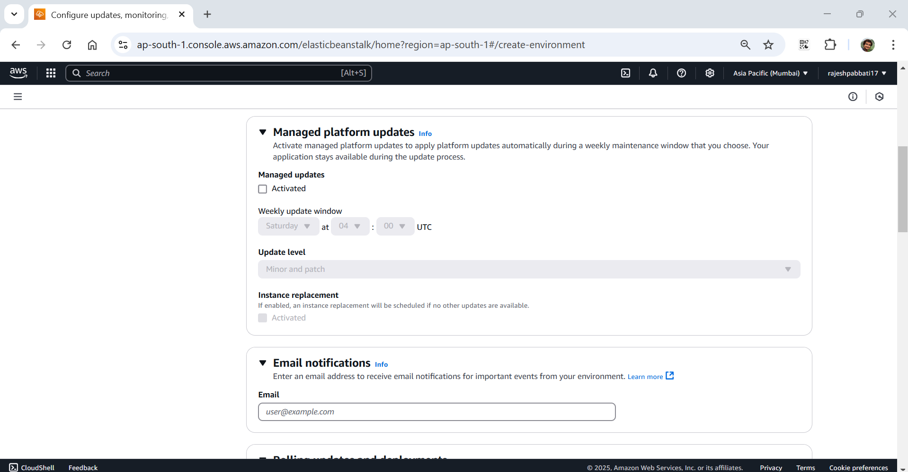

Review and submit

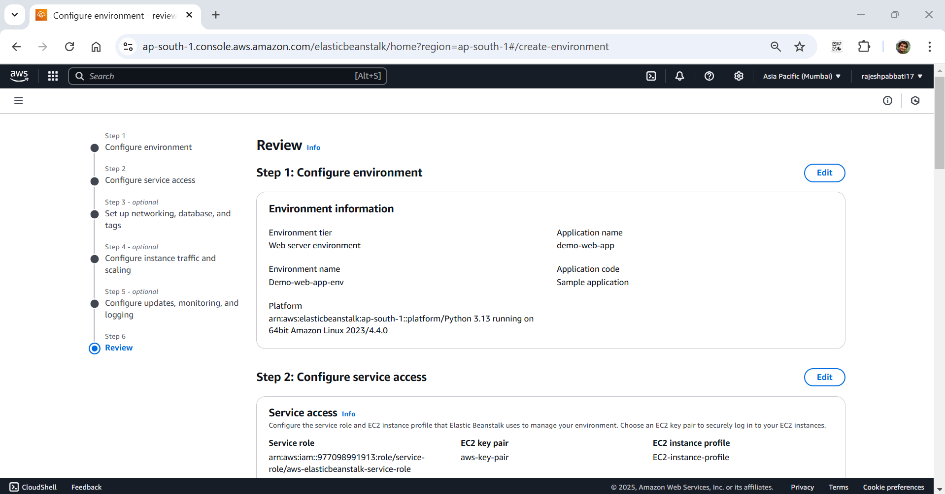

Application creating Health is Grey

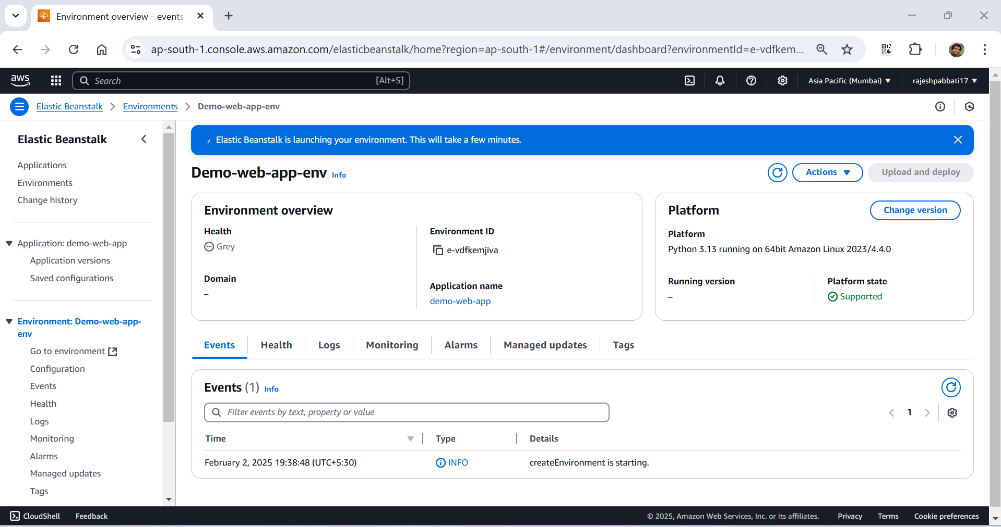

Application created health is green. Click on Domain link

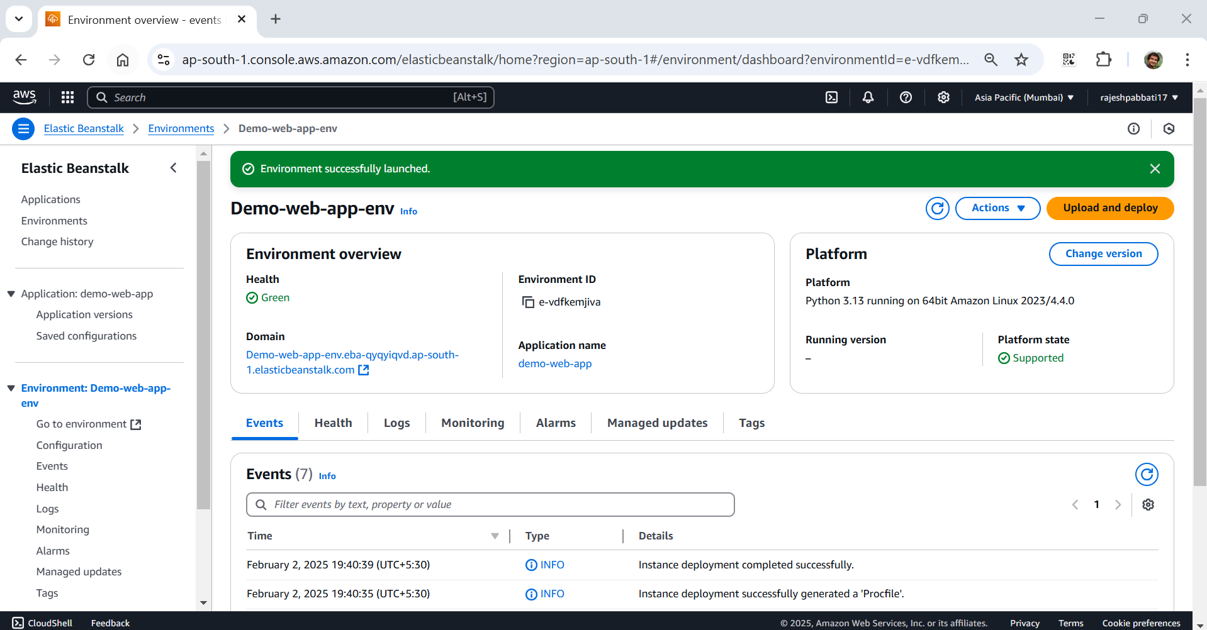

Application opened in new tab.

